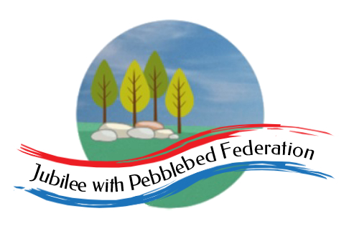
The Jubilee Hub of The Jubilee with Pebblebed Federation
Subject Intent Statement for PSHE
Our Vision
‘Be who God meant you to be and you will set the world on fire.’
St Catherine of Siena
Intent
In the Jubilee Hub of The Jubilee with Pebblebed Federation, Personal, Social and Health Education (PSHE) teaching enables our children to become healthy, independent and responsible members of their community. It aims to help them to understand how they are developing personally and socially, and tackles many of the moral, social and cultural issues that are part of growing up. In an ever-changing world, it is important that they are aware, to an appropriate level, of different factors which will affect their world and that they learn how to deal with these so that they have good mental health and well-being.

PSHE is taught throughout the Jubilee Hub in such a way as to reflect the overall aims, values, and ethos of a Church of England school.

We provide our children with opportunities for them to learn about rights and responsibilities and appreciate what it means to be a member of a diverse society outside of their own community in Devon. Our children are encouraged to develop their sense of self-worth by playing a positive role in contributing to school life and the wider community and making decisions.

Children will be taught about forming relationships and how to form positive relationships in order to keep themselves safe. They will learn about changes in their body as they grow, including during puberty.

PSHE plays an important role, along with all other curriculum areas, particularly RE, in promoting the spiritual, moral, social, and cultural development of our children.
Implementation
- PSHE is taught as discrete lessons following the rolling program of PSHE using the 1 Decision resource, these are taught to an appropriate level depending on the age of the children.
- The modules covered in the discrete teaching of PSHE are;
- Keeping/Staying Safe
- Keeping/Staying Healthy
- Relationships
- Being Responsible
- Feelings and Emotions
- Computer Safety
- Money Matters/The Working world
- A World Without Judgement
- Lessons will be differentiated for children with SEND and made appropriate to their developmental age.
- Work will be recorded in the children’s own 1 Decision work book and class scrap books.
- Circle time, stories and class discussion are used to address issues which are specific to a class or child.
- PSHE will be covered in other curriculum areas such as Science, PE, RE and Social History.
- We recognise and take part in national days such as Mental Health Awareness Day and Anti Bullying Week.
- We use the ‘Normal Magic 10 a day’ as a strategy to promote positive mental health.
- Children are encouraged to share their feelings with others in a safe environment.
- Visitors and visits are used to enhance our teaching of PSHE for example CAP, NSPCC and Life Skills.
- The monthly newsletter includes a section on wellbeing to support families.
- The Good Samaritan Awards are used to promote ‘Looking After Ourselves and Looking After Others.’
- The older children in each school are trained Mental Health Ambassadors to support their peers in dealing with mental health.
- British values and rights and responsibilities are taught.
- School worship time regularly makes links with PSHE.
- Using the monitoring cycle the SLT and governors will monitor the effectiveness of the PSHE teaching across the federation.
- Use of Philosophy for Children (P4C) encourages questioning and challenge - to voice and discuss opinions through a structured enquiry.
- PSHE will be assessed using the school assessing system Target Tracker this will show coverage and attainment.
Intended Impact
By the end of KS2 the children of the Jubilee Hub will be healthy, independent and responsible members of their community both in school and within the wider community. They will know their rights and responsibilities and appreciate what it means to be a member of a diverse society outside of their own community in Devon.

They will understand how they are developing personally and socially, and will be able to deal with many of the moral, social and cultural issues that are part of growing up. They will be aware, to an appropriate level, of different factors which will affect their world and have strategies of how to deal with these so that they have good mental health and well-being.

They will understand the importance of healthy relationships and use this knowledge, along with the ability to make considered decisions and having self-worth, to form positive relationships and stay safe.

