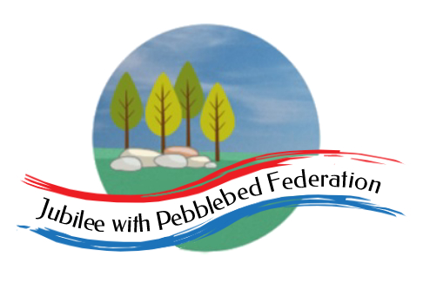
The Jubilee Hub of The Jubilee with Pebblebed Federation
Subject Intent Statement for Collective Worship
Our Vision
‘Be who God meant you to be and you will set the world on fire.’
St Catherine of Siena
Intent
In the Jubilee Hub of the Jubilee with Pebblebed Federation, daily acts of Collective Worship are underpinned by the school’s ethos, mission statement and vision, through which children are encouraged, in the words of St. Catherine of Siena, to ‘Be who God meant you to be and you will set the world on fire’. Children are explicitly taught to understand and apply the school’s Christian values in their lives. These values of courage, creativity, peace, trust, forgiveness, justice, thankfulness, compassion, friendship, hope , truthfulness, humility, generosity, wisdom, perseverance, service, responsibility, respect and reverence, which are taught in turn each half-term, are underpinned by the core value of love, as expressed in Colossians 3 verse 21.

It is intended that these times of gathering together will support the children to develop their own sense of identity as children of God, loved and precious to Him and that they will also develop a spirituality that enables them to appreciate and care for God’s creation and be inspired to look after others. Through these times of worship, prayer and discussion, children are encouraged to develop their understanding of the Trinity: God the Father, God the Son and God the Holy Spirit. They develop their knowledge of core Bible stories and Christian teachings and relate these to beliefs and teachings from other faiths and traditions, developing tolerance, understanding and respect for the beliefs of others.

Implementation
During Collective Worship, children are encouraged to participate in times of quiet contemplation and prayer. They listen to and discuss inspirational stories from the Bible as well as from other faiths and traditions. Children learn to express worship to God in singing and by responding in a range of ways, including writing their own prayers and recording their thoughts and ideas in a reflective journal.

Worship follows a liturgical pattern, with opening and closing prayers, spoken or sung. It should always include a story, reflection or teaching as well as a hymn, song or other opportunity to respond and a time for quiet contemplation or prayer. Wherever possible, worship includes ‘dressing the altar’ with the symbols of the Trinity: a Bible, a cross and a candle.

Each half term one of the values is explored in more detail. The ‘Values for Life’ scheme forms the basis for teaching each of the values and is supplemented by additional material from ‘Out of the Box’/ Roots and Shoots and teachers’ own experiences and stories. These will explore how the value might be expressed individually and corporately, both locally in school, family and community life and in relationship to issues in the wider world. A wide range of stories and literature is introduced in times of worship, from across a range of times and cultures. A school worship display highlights key themes and vocabulary linked to the current value. At the end of each half-term, children are encouraged to respond by reflecting on the value explored in their reflective journals and/or by planning and leading times of class worship.

Through the year, the schools celebrate the church calendar and observe celebrations such as Harvest, Remembrance, Christmas, Easter and Pentecost, with special services, many of which are shared with the wider school and church community and in which the children take a leading role. Periodically, the whole school will also participate in a Collective Worship project linked to a particular theme or celebration, to explore this in greater depth. Reflective stations may be set up across the school to support children’s engagement in such projects and to give them opportunities to respond.

In each classroom, there is an area dedicated to prayer and worship, where the children can find a focus for their own prayer and worship. The use of outdoor dedicated prayer spaces is also encouraged, so that children may enjoy and respond prayerfully to the beautiful environment surrounding the school.

Included in the regular weekly and monthly pattern of worship will be a focus on the themes of the International Community of the Cross of Nails: peace, justice and reconciliation. The Coventry Liturgy of Reconciliation is used on a regular basis and children are also encouraged to explore the work of some of the other partners within this special faith community.

Intended Impact
- Pupils develop the skills of quiet contemplation and peaceful reflection and are able to recognise and talk about some of the benefits of taking time regularly for personal reflection.
- Pupils develop a sense of belonging and acceptance within the school community and a sense of shared identity and values as members of this community.
- Pupils are able to explain the shared values of their school community.
- Pupils recognise the importance of values such as love, peace and forgiveness in enabling them to live and work in harmony with others.
- Pupils are aware of events within the Church calendar and how these are celebrated in the local community as well as in the wider church family.
- Pupils are able to recall stories, from the Bible as well as from other sources and traditions, which can give helpful instruction or advice when negotiating some of life’s challenges.
- Pupils are presented with opportunities to pray and develop their spirituality and relationship with God, should they wish to.

