Broadhembury Church of England Primary School
Honiton
Devon
EX14 3NF
Headteacher: Mrs Katie Gray
(01404) 841304
admin@broadhembury.devon.sch.uk www.broadhembury.devon.sch.uk fax: (01404) 841778

5th February 2021
Dear Parents,

Welcome to the February edition of our Newsletter. Although not all of the children have been in school this half term, we wanted to share some of our learning with everyone both at home and at school. For those of you who haven’t been in school we hope you are all well and are managing to enjoy your home learning, as always if you have any problems, please do get in touch with us.

In Class 1 Mrs Symonds has been really impressed by all of the work that you have sent into school. Here are some examples of your fabulous work. Well done everyone!
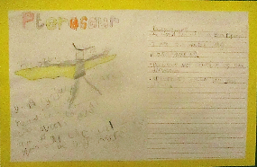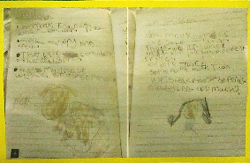
For Class 1’s Dino-Dinners unit, the children learnt how to write using two different voices- the dinosaurs and the authors. They were able to write factual information using some really technical words, as well as some more creative and informal writing in the voice of the dinosaur.
As part of Class 1’s continental drift topic Mrs Symonds hopes that you all enjoyed watching ‘Ice Age 4’ and that it helped those of you at home to understand a little bit more about what the Earth looked like in the time of the dinosaurs. The children, both those at home and at school, have created some wonderful timelines.

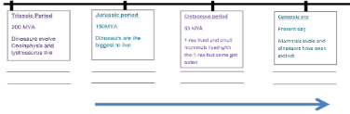
Well done Archie, I think you have become a computer whizz over the last few weeks!

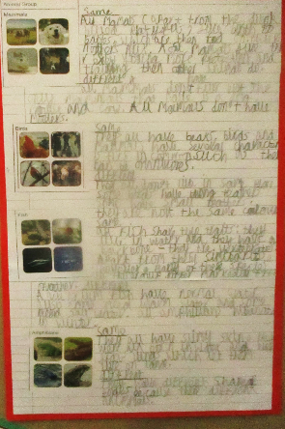
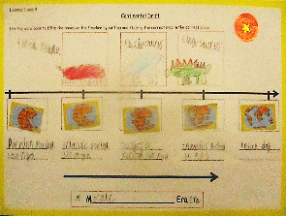
Some lovely work Max - you have really thought hard about this!

In Science, the Class 1 children have been learning about animals (including humans). They have begun to classify different animals and will now be learning about bones in the human body as well as looking at dinosaur bodies.

Class 2’s topic for the Spring term is all about the Saxons and Vikings. In history and geography, they have begun learning about the Anglo Saxon invasion of the British shores and how they lived. The children have started to discover and explore evidence of the Anglo Saxons settlements in Exeter. In computing, the children have researched and put together a presentation about Anglo Saxon artefacts that have been found in Britain today. In art, the children used a printing technique to recreate Anglo Saxon patterns and in music, the children have learnt the nursery rhyme ‘When Good King Arthur Ruled This Land’, looking at musical notation and re-writing some of its lyrics.

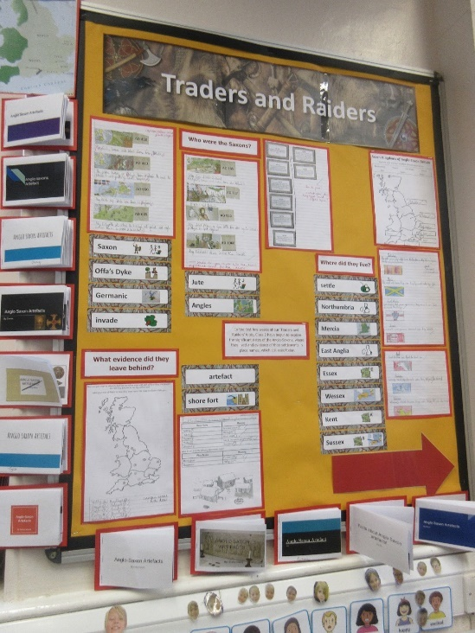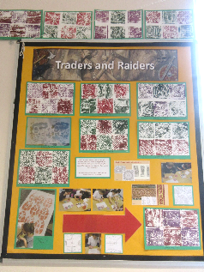

It is wonderful to see learning from both the children in school and those working at home on display together in the classroom.

Miss Watts would like to say a big well done to all the home learners in Class 2. She has been so pleased with the effort you are putting in and the work she is receiving. The children in school have also enjoyed seeing those at home in their regular morning daily dashboard and end of day story ‘Google meets’. Some of the children in school have also taken turns to read a chapter of the class book to both the children in school and at home. Keep up the good work home learners!

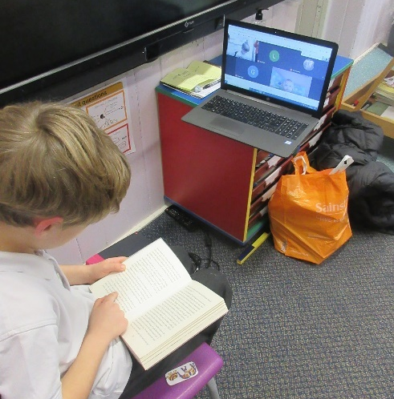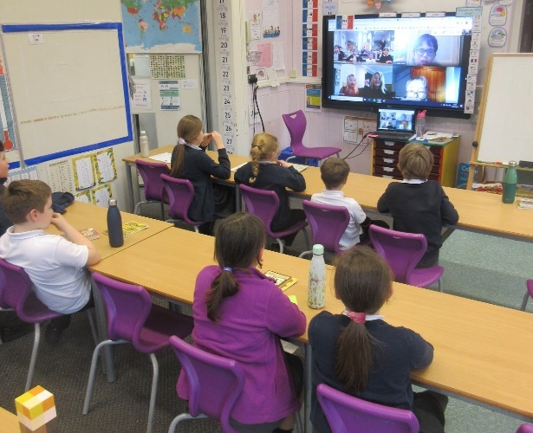

After a busy time getting to grips with home learning in the first few days of term, we were unable to share our Christmas news. Firstly, congratulations as the children won the parish’s Christmas window competition. Well done!

Secondly, a fantastic fundraising effort to celebrate, as the ‘Santa Run’, held on the penultimate day of the Autumn term, raised £444 from across the Jubilee with Pebblebed Federation for the Exeter Leukemia Fund (E.L.F). Thank you to everyone who donated!

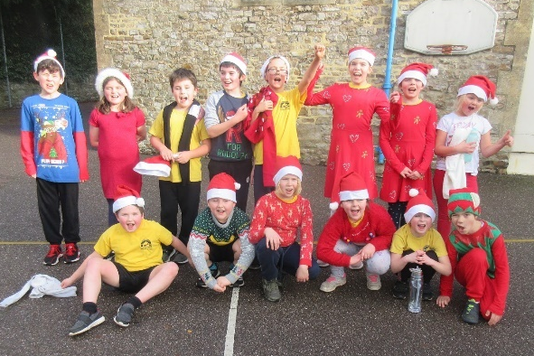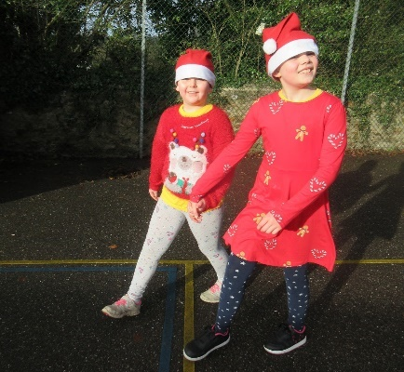

Thank you all for your continued support.
God bless and have a lovely weekend.
Best wishes from Katie Gray and the staff at Broadhembury CE School

Question of the week

Class One:
Olivia wants to know more about the human body. Her question is ‘How does the human skeleton stay together?’ Have a think about this one and let me know what you’ve talked about.

Class Two: Why did the Saxons want to settle in Britain?

Key Dates
Spring Term 2021
15th – 20th February – Spring Half Term.
Thursday 1st April 2021 – Last day of the Spring Term.
BROADHEMBURY BRIDGES
Class 1:
We will be beginning our sharing assembly online this Friday. If you can join us at 3pm, that would be lovely. We will be able to give out Broadhembury Bridge awards again and have a chat about everything that you have been doing.

Class 2 : Friday 29th January - Evie for her fantastic effort in home learning!

Class One
Wellbeing
There has been much press in recent months about children’s mental health. As part of our drive to support this we are going to include something each month in the newsletter about Health and Wellbeing. We hope you find this section useful. If you have any topics you would like us to find some helpful tips about, please let us know.

As the New Year has started, we need to continue to look after not only our physical health but also our Mental Health. Please see the link below for the NHS website that offers support for families.
https://www.nhs.uk/using-the-nhs/nhs-services/mental-health-services/cypmhs-information-for-parents-and-carers/

In school we continue to use the '10 a day' choices towards balancing our mental health, please see below. We have shared this with you previously so hopefully they will be familiar to you, it would be really great and beneficial for you to use these ideas as a family to promote positive mental health, particularly at this tricky time.
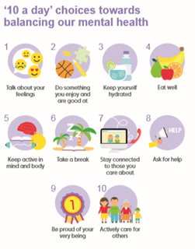

Drop off and Pick up
Please can all parents and carers remember to keep 2 metres apart at drop off and collection time? This is important for all of our safety to reduce the spread of Covid-19. If possible adults and teenagers should wear masks outside the school gate. Thank you for your help with this.

Free School Meals
If your circumstances have changed as a result of the Covid-19 crisis your child may have become eligible for free school meals. This will also bring extra funding to the school, which will be used to help your child. For an instant decision or to learn more please go online at https://www.devon.gov.uk/educationandfamilies/school-information/school-meals.

Collective Worship Activity
This term we will be focussing in school on the value of Trust. We hope your family will find these ideas helpful as you explore the value and have fun together. If the children bring back something that you have done at home linked to the Collective Worship activity, or can talk about a discussion they’ve had at home linked to it, then Mrs Gray will award them with a new special sticker.

