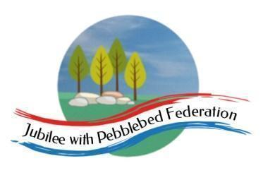

Class 1 Home Learning for the week beginning 11th January 2021
 | Phonics (30 mins) | Reading (30 mins) | Literacy (30 mins) | Maths (30 mins) | Worship (15 mins)  Daily Dashboard (15 mins) | PE (15 minutes) | Afternoon Project (1hr) | Mental Health
Monday | Resource Room Phonics  Revisiting Phase 2 -Unit 1  /s/ as ‘s’  Blending s-a-d, s-a-t using the pictures in Google classrooms to help.  Reception  Phase 3 - Unit 6  /v/ as ‘v’  Year 1  Phase 5 - Unit 20  Language Session  Year 2  Contractions - watch the video  https://www.bbc.co.uk/bitesize/topics/zvwwxnb/articles/zcyv4qt (This is aimed at slightly older children but I think you will be able to understand it). | Phase 2 Phonics Group  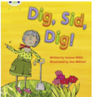  Share this book with your child this week. Can they begin to join in with some of the refrains such as ‘dig Sid, dig.’  Reception  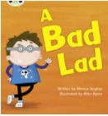  I have allocated this book to you this week. Share it with your grown ups and have a go at blending some of the words together. You know all of these sounds and some of the tricky words.  Year 1  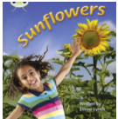  I have allocated this book to you this week. Read it aloud to your grown ups if you can.  Make sure that you recognise the different ways of saying /ur/. Can you blend the sounds in the words?  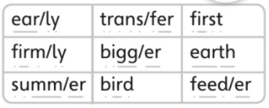  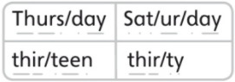  Year 2  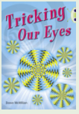  I have allocated this book to you this week. Read it aloud to your grown ups if you can.  Think about the tricky words in this book. Focus on the ones you find challenging to read. | 1:1 Children/Reception  Talk with your grown ups about the dinosaur that you have drawn and then practise talking or get your grown up to talk to you as if they or you were the dinosaur!  Year 1  Using the dinosaur that you designed last week, I would like you to write a short piece of writing AS IF YOU WERE YOUR DINOSAUR. How do you think they would talk? Read the poems from the dinosaurs in Dino-Dinners before you begin. Remember to write in full sentences using capital letters, punctuation and finger spaces. Try to make sure that you form your letters as you have been taught.  I wonder whether you could use an exclamation mark instead of a full-stop anywhere? Watch the video on exclamation marks in the link. https://www.bbc.co.uk/bitesize/topics/z8x6cj6/articles/z3dcmsg  Year 2  Create a fact file for your invented dinosaur. I have put all instructions and an example on Google Classroom. I have also put up the information parts from Dino-Dinners to help you. | Numberblocks Children/Reception  This week we will be learning about ‘Six’  https://www.bbc.co.uk/iplayer/episode/b08pgksd/numberblocks-series-2-six  Play a simple board game with a dice. Practise counting the dice rolls up to 6 as you move around the board.  Year 1  For each maths lesson, you will need to watch the video and then complete the worksheets that I have allocated to you. Send them back completed to me each day using the ‘turn in’ button.  Numbers to 50  Counting to 50 (1) - Power Maths  https://www.bbc.co.uk/bitesize/articles/znfk8xs  Year 2  For each maths lesson, you will need to watch the video and then complete the worksheets that I have allocated to you. Send them back completed to me each day using the ‘turn in’ button.  Recognise Equal Groups  https://whiterosemaths.com/homelearning/year-2/week-1-number-multiplication-and-division/ | Trust  Look at the Powerpoint each day for Worship.  Daily Dashboard  Look at the Powerpoint each day for Daily Dashboard.  Watch the video for telling the time  https://www.bbc.co.uk/bitesize/topics/zhk82hv/articles/zcmdwxs | https://www.youtube.com/user/thebodycoach1 | RE  SEND  https://www.bbc.co.uk/iplayer/episode/m000pncd/something-special-were-all-friends-series-12-25-happy-diwali  Reception/ Year 1/ Year 2  https://classroom.thenational.academy/lessons/what-is-the-christian-place-of-worship-6hj3ac  Although we cannot visit the church, you are on a clue finding mission to see if you can find things to show that the church is important and sacred to Christans. Can you draw any clues that you can see and send them to me. | 10 a Day’ for Mental Health - (5)’Keep Active in Mind and Body’..  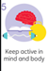  Turn a walk into an exciting new adventure. Your goal is to notice as many birds, bugs, creepy-crawlies, and any other animals as you can. Anything that walks, crawls, swims, or flies is of interest, and you’ll need to focus all of your senses to find them, especially the little ones.  When you go for a walk each choose a colour and see how many of each colour you can spot.  Wild workouts with Andy.  https://www.bbc.co.uk/iplayer/episode/p06tmn51/andys-wild-workouts-series-1-1-under-the-sea
Tuesday | Resource Room Phonics  Revisiting Phase 2 -Unit 1  /a/ as ‘a’  Blending s-a-d, s-a-t using the pictures in Google classrooms to help.  Reception  Phase 3 - Unit 6  /w/ as ‘w’  Year 1  Phase 5 - Unit 20  Assessment Session  See if you can get your grown-up to help you with this.  Year 2  Contractions  https://www.activelearnprimary.co.uk/resources#spag  Fill the gaps (first video only) | Phase 2 Phonics Group  Share this book with your child this week. Can they begin to join in with some of the refrains such as ‘dig Sid, dig.’  Reception  I have allocated this book to you this week. Share it with your grown ups and have a go at blending some of the words together. You know all of these sounds and some of the tricky words.  Year 1  I have allocated this book to you this week. Read it aloud to your grown ups if you can.  Practise using the glossary. What new words have you learnt today?  Year 2  I have allocated this book to you this week. Read it aloud to your grown ups if you can.  As you read today, think about this question:  Why does the writer ask us questions/give us instructions? | SEND/Reception  Talk about what you did yesterday or at some time in the past.  I have uploaded some symbol cards to help you.  Year 1  Have a look on Google Classroom for your assignment. I would like you to see if you can fill in facts for a dinosaur of your choice. I have done one to show you. Return your work to me using the ‘turn in’ button.  Year 2  https://www.bbc.co.uk/bitesize/topics/zrqqtfr/articles/z3dbg82  Watch the video and do the quizzes to help you learn about the past tense. I have allocated this on your Bug Club Grammar account too so have a go at the games to help you to understand the difference.  Now, write about one of the dinosaurs in the book, using the present tense as if dinosaurs were still alive. | Numberblocks Children/ Reception  Continuing to practise learning about ‘Six’  https://www.bbc.co.uk/iplayer/episode/b08pgksd/numberblocks-series-2-six  Can you find a cuboid (such as a tissue box) and make your own dice so that you can practise recognising the number to 6 without counting.  Year 1  Watch the video, complete the worksheet and then turn it in.  https://www.bbc.co.uk/bitesize/articles/znfk8xs  Tens and Ones (within 50)  Year 2  Make equal groups  https://whiterosemaths.com/homelearning/year-2/week-1-number-multiplication-and-division/ | Trust  Look at the Powerpoint each day for Worship.  Daily Dashboard  Look at the Powerpoint each day for Daily Dashboard.  Sing the cheerleader song for days of the week https://www.bbc.co.uk/teach/supermovers/ks1-english-days-of-the-week/zd8njhv | Dance  School Radio - Dance: Key Stage 1 - Time to Move, Dinosaurs, 1. Mary Anning (bbc.co.uk) | Science  1:1 Children/Reception  Go on a nature walk and see what you can find. I have put a tick sheet in the resources which might help you.  Year 1/Year 2  Have a look at the powerpoint called ‘Observing Animals’ (see Google Classrooms for resource).  Go outside with a recording sheet (see Google Classroms for resources).  If you can, go for a short walk. Can you find and name some animals along your way including where you found them and which animal group they belong to.
Wednesday | Resource Room Phonics  Revisiting Phase 2 -Unit 1  /t/ as ‘t’  Blending s-a-d, s-a-t using the pictures in Google classrooms to help.  Reception  Phase 3 - Unit 6  /x/ written as ‘x’  Year 1  Phase 5 - Unit 21  /ow/ written as ‘ou’  Year 2  Contractions  https://www.bbc.co.uk/bitesize/topics/zvwwxnb/articles/zcyv4qt  Fill the gaps (second video) | Phase 2 Phonics Group  Share this book with your child this week. Can they begin to join in with some of the refrains such as ‘dig Sid, dig.’  Reception  I have allocated this book to you this week. Share it with your grown ups and have a go at blending some of the words together. You know all of these sounds and some of the tricky words.  Year 1  I have allocated this book to you this week. Read it aloud to your grown ups if you can.  Practise using the glossary. What new words have you learnt today?  Year 2  I have allocated this book to you this week. Read it aloud to your grown ups if you can.  - Use technical language as you talk about the contents page, headings, glossary, fact boxes, labels, etc.  - How does it feel to see a page without instructions or questions? | SEND/Reception  Play the game ‘I packed my suitcase’ but changed it to ‘I saw a dinosaur’ For example ‘I saw a dinosaur and he had sharp teeth’ then expand with your child and say ‘I saw a dinosaur and he had sharp teeth and a long tail’ and so on adding each time and emphasising the and to show that you are adding something.  Year 1/ Year 2  Watch the BBC video https://www.bbc.co.uk/bitesize/articles/zjdxhbk  Now have a go at the Activity 1 and 2.  Now, go to Google Classrooms where I have put some more sentences for you to join using co-ordinating conjunctions. | Numberblocks Children/ Reception  Continuing to practise learning about ‘Six’  https://www.bbc.co.uk/iplayer/episode/b08pgksd/numberblocks-series-2-six  ‘I Spy Number Six’  Find this sheet on Google Classroom. Can you spot all of the representations of 6?  Year 1  Watch the video. We don’t have the worksheets, so I have put up some work onto Google Drive for you to complete and turn in.  One more one less  https://whiterosemaths.com/homelearning/year-1/week-11-number-place-value-within-20/  Year 2  Add equal groups  https://whiterosemaths.com/homelearning/year-2/week-1-number-multiplication-and-division/ | Trust  Look at the Powerpoint each day for Worship.  Daily Dashboard  Look at the Powerpoint each day for Daily Dashboard. | https://www.youtube.com/user/thebodycoach1 | History  SEND/Reception  https://www.bbc.co.uk/iplayer/episode/b09qmd1q/something-special-were-all-friends-series-11-10-dinosaurs  Year 1/ Year 2  Watch the dinosaur powerpoint (see Google Classroom for resources).  Now open the dinosaur powerpoint about ‘Dinosaur myths and facts’ and see if you can put the statements into the correct column.
Thursday | Resource Room Phonics  Revisiting Phase 2 -Unit 1/p/ as ‘p’  Blending s-a-d, s-a-t, p-a-t using the pictures in Google classrooms to help.  Reception  Phase 3 - Unit 6  Language session  Year 1  Phase 5 - Unit 21  /oi/ written as ‘oy’  Year 2  Contractions  https://www.bbc.co.uk/bitesize/topics/zvwwxnb/articles/zcyv4qt  Highlight the words | Phase 2 Phonics Group  Share this book with your child this week. Can they begin to join in with some of the refrains such as ‘dig Sid, dig.’  Reception  I have allocated this book to you this week. Share it with your grown ups and have a go at blending some of the words together. You know all of these sounds and some of the tricky words.  Year 1  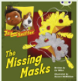  I have allocated this book for you to share with your grown ups if you can.  Look at the front and back covers. Can you predict what might happen in the story?  While you read the story, talk about what the problem is, what the baddie is and who the heroes are. What is the solution?  Year 2  What are lithops?  Can you draw an optical illusion of your own? | SEND/Reception  Have a look at different pictures of cats. Can you sign ‘cat’. You make a v with your fingers and draw them outwards from your mouth like whiskers.  Draw and label a picture of a cat  Year 1/ Year 2  Today, I need to you do a little bit of research. You could use the internet as long as you have an adult with you or you could use books. Can you find out a little bit about cats. I have uploaded some information just in case you don’t have what you need to find out. You can use that if you need to.  https://education.cats.org.uk/for-kids/about-cats/10-amazing-facts-about-cats/  Can you add your new information to the chart I have assigned to you. Y1 you will recognise this chart from Tuesday’s assignment. | Numberblocks Children/ Reception  Continuing to practise learning about ‘Six’  https://www.bbc.co.uk/iplayer/episode/b08pgksd/numberblocks-series-2-six  If you have any building blocks, Duplo or Lego, can you find different ways to make 6 using 2 groups of blocks (eg 1 block and 5 blocks, 2 blocks and 4 blocks, 3 blocks and 3 blocks).  Year 1  https://www.bbc.co.uk/bitesize/articles/zcsftrd  Representing numbers to 50  Year 2  Multiplication using the x symbol  https://whiterosemaths.com/homelearning/year-2/week-1-number-multiplication-and-division/ | Trust  Look at the Powerpoint each day for Worship.  Daily Dashboard  Look at the Powerpoint each day for Daily Dashboard.  Watch the video to learn about the seasons of the year |  | Computing  https://scratch.mit.edu/projects/editor/?tutorial=getStarted  Play the tutorial - Getting Started,  Now, see if you can add a backdrop and choose a sprite.  PSHE  SEND/Reception  Circle of Trust  My Caring Community  https://classroom.thenational.academy/lessons/my-caring-community-75hkgc  Year 1/Year 2  https://schools.1decision.co.uk/info/videos-5-8/growing-in-our-world-scorm/index.html  Watch the video and then complete the baseline and the ‘What can I do now’ sheet in Google Classroom.
Friday | Resource Room Phonics  Revisiting Phase 2 -Unit 1  /s/ /a/ /t/ /p// as ‘s’ ‘a’ ‘t’ ‘p’  Reception  Guided Read this morning  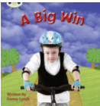  Year 1  Phase 5 - Unit 21  Language Session  Year 2  Contractions  https://www.bbc.co.uk/bitesize/topics/zvwwxnb/articles/zcyv4qt  Quiz | Phase 2 Phonics Group  Share this book with your child this week. Can they begin to join in with some of the refrains such as ‘dig Sid, dig.’  Reception  I have allocated this book to you this week. Share it with your grown ups and have a go at blending some of the words together. You know all of these sounds and some of the tricky words.  Year 1  I have allocated this book for you to share with your grown ups if you can.  Complete the worksheet allocated to you.  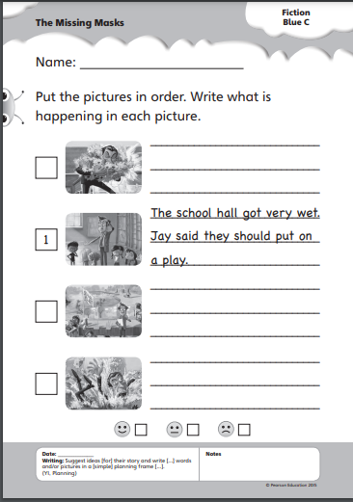  Year 2  I have allocated this book to you this week. Read it aloud to your grown ups if you can.  Please complete the worksheet for this book.  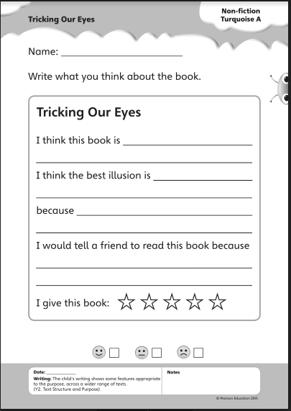 | SEND/Reception  https://www.bbc.co.uk/iplayer/episode/p080ch95/mr-tumble-songs-22-old-macdonald-had-a-farm  Watch Mr Tumble as he sings Old MacDonald had a Farm. Can you sign along with him? You know the sign for cat so could you add your own verse?  Year 1/Year 2  Can you draw me a story map for your chosen cat, following the format that we have used for Dino-Dinners. Look back at all your work this week to help you.  Please send them to me by taking a photograph or scanning them. Use the original story map in Google Classroom resources to help you. I can’t wait to see them. | Numberblocks Children/ Reception  Continuing to practise learning about ‘Six’  https://www.bbc.co.uk/iplayer/episode/b08pgksd/numberblocks-series-2-six  Can you count 6 of different things such as claps, skiips, hops and jumps. Take some photographs if you can and send them in to us ad admin@broadhembury.devon.sch.uk  Year 1  https://www.bbc.co.uk/bitesize/articles/zwbwr2p  Comparing numbers of objects  Year 2  Multiplication sentences using pictures  https://whiterosemaths.com/homelearning/year-2/week-1-number-multiplication-and-division/ | Trust  Look at the Powerpoint each day for Worship.  Daily Dashboard  Look at the Powerpoint each day for Daily Dashboard. | https://www.youtube.com/user/thebodycoach1 | Music  SEND/ Reception  https://classroom.thenational.academy/lessons/the-woodland-part-1-6nj30t  Year 1/ Year 2  The tempo is the speed of a piece of music. Watch the lesson below to learn more about tempo.  https://classroom.thenational.academy/lessons/identifying-tempo-changes-in-tempo-cru64t

