Week beginning 1st June 2020
Welcome back to another two weeks of home learning, I have really enjoyed receiving pictures of the things you are doing at home such as lego ancient Greek chariots and homemade greek pottery! It is also great to see how some of you are thinking about your mental well-being whilst learning at home.
I hope you enjoyed the sunny May half term we had - aren’t we lucky? Do keep updating me on all you’re getting up to!
Attached to the Parents-Coronavirus page is an exciting ‘Book-tastic Competition’ you might like to enter- have a look!
Remember, if you have any questions or you would like to email a picture of some lovely work you have been doing, please email admin@broadhembury.devon.sch.uk.
EVERY DAY | Joe Wicks continues to bring out fun PE at home videos on YouTube to do in your living room EVERY MORNING - watch out for your pets though!  15 mins ‘Spelling Shed’  15 mins ‘Bug Club Grammar’  15 mins ‘Times Table Rockstars’  30 mins ‘Bug Club’ Reading (with comprehension ‘bug’ questions)  30 mins reading a book/magazine of your choice  Games and books will be changed regularly by Miss Watts.  60 mins Maths lesson (‘White Rose’ website video then practice book pages/online games)
Monday 1st June  NON PUPIL DAY | You might like to…  Read the story of The Battle of Marathon in your pack. Consider how this legend has continued into modern life. How many ‘marathons’ are run worldwide today?  Research some famous marathon runners such as Haile Gebrselassie, Paula Radcliffe and Mo Farah.  Create a fact file in your green exercise book on a chosen marathon runner.
Tuesday 2nd June | Maths - go to this link https://whiterosemaths.com/homelearning/, find the year group you are working in, watch the video for today’s lesson and find the appropriate page in one of your practice books (it will normally have the same title). If you have done that page, don’t worry, just watching the video, finding maths games on that topic and doing TT Rockstars is enough.  If you normally go to Class 1 for maths - you are working on year 2 maths (photocopied pages in your folder outside school).  If you normally go to Class 1 for phonics: I have allocated you a unit called ‘Spelling with Phonemes’. Please watch the video today and then each day, re-watch the video and have a go at one of the games (there are 6 games in total). Remember to think about each digraph (2 letters making 1 sound) as you write them.  Daily Project – Science ‘Animals Including Humans’  Animals, including humans, need the right types and amount of nutrition, and they cannot make their own food; they get nutrition from what they eat.  Follow this link https://www.bbc.co.uk/bitesize/topics/zrffr82 to watch three videos about health.
Wednesday 3rd June | Maths - go to this link https://whiterosemaths.com/homelearning/, find the year group you are working in, watch the video for today’s lesson and find the appropriate page in one of your practice books (it will normally have the same title). If you have done that page, don’t worry, just watching the video, finding maths games on that topic and doing TT Rockstars is enough.  If you normally go to Class 1 for maths - you are working on year 2 maths (photocopied pages in your folder outside school).  If you normally go to Class 1 for phonics: I have allocated you a unit called ‘Spelling with Phonemes’. Please watch the video today and then each day, re-watch the video and have a go at one of the games (there are 6 games in total). Remember to think about each digraph (2 letters making 1 sound) as you write them.  Daily Project - RE  How and why do people try to make the world a better place?  Most Christians believe that Jesus was not just a good teacher, but that he also sacrificed his life to save humanity. Many Christians try to follow his example by putting the needs of others before their own. Some people do this in world-changing ways.  Research the life of a Christian e.g. Martin Luther King, Gladys Aylward, Mother Teresa,  Corrie Ten Boom, Desmond Tutu, Harriet Tubman, Rosa Parks, Pope Francis, and/or a local example in your green exercise book.  Complete your investigation by finding answers to these 6  questions:  o Who was this person?  o Where and when did this person live?  o What was this person’s struggle, their way of changing the world?  o What did this person say about following Jesus or being a Christian?  o What Christian teachings did they put into practice? (Link with ideas you have  already learned about)  o In what ways did they make the world a better place?
Thursday 4th June | Maths - go to this link https://whiterosemaths.com/homelearning/, find the year group you are working in, watch the video for today’s lesson and find the appropriate page in one of your practice books (it will normally have the same title). If you have done that page, don’t worry, just watching the video, finding maths games on that topic and doing TT Rockstars is enough.  If you normally go to Class 1 for maths - you are working on year 2 maths (photocopied pages in your folder outside school).  If you normally go to Class 1 for phonics: I have allocated you a unit called ‘Spelling with Phonemes’. Please watch the video today and then each day, re-watch the video and have a go at one of the games (there are 6 games in total). Remember to think about each digraph (2 letters making 1 sound) as you write them.  Daily Project – PE/Mental Health  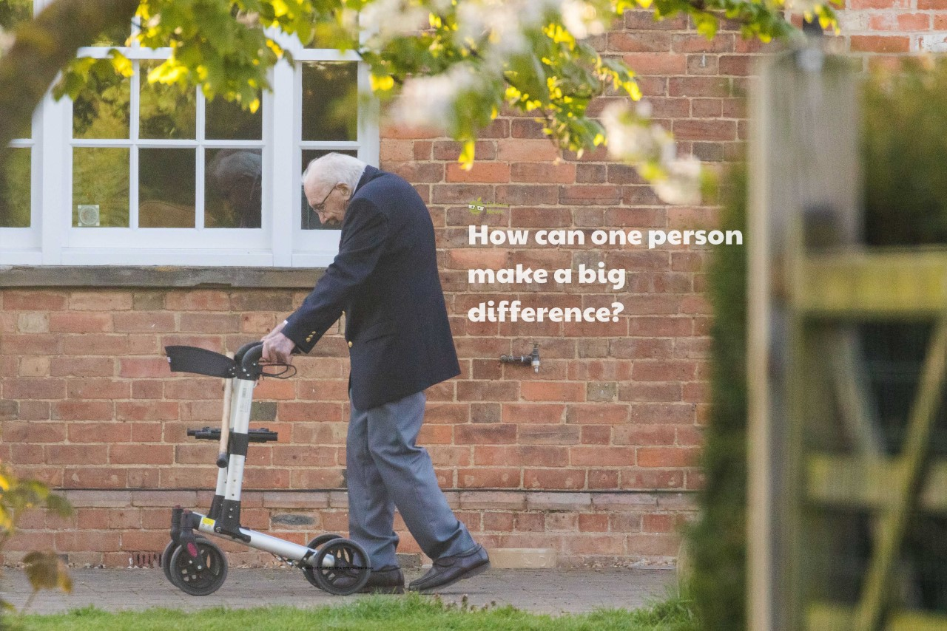  PE - This week, go to https://www.youtube.com/watch?v=bSlZcs-O9aM for a football -kick ups session.  Mental Health - 99-year-old British war veteran, Captain (Now Colonel) Tom Moore has completed 100 laps of his 25m back garden in Marston Moretaine, Bedfordshire! He has raised over £28 million for Britain's National Health Service (NHS) and has received donations to his fundraising challenge from all around the world! Captain Tom began raising funds to thank NHS staff who helped him with treatment for cancer and a broken hip, he originally aimed to raise just £1000 but quickly passed his target!  On the website there is a ‘Colonel Tom Moore Resource’ sheet for you to read all about his amazing achievements.  Sometimes it’s not the biggest actions that can have the biggest impact and that all of the things that we do affect the world around us! Colonel Tom didn’t even leave his garden but managed to raise a lot of money and raise the spirits of the nation! Can we think of anything we can do at the moment to help others?  Challenge 1 – Write a letter or thank you card and send it to someone who has made a difference in your local community, this could be for a teacher, family member or neighbour.  Challenge 2 – Draw a picture of Captain Tom Moore completing his challenge.  Captain Tom Moore fundraising news story https://bbc.in/2Y0hMsC  Useful Video – Tom Moore receiving a Pride of Britain Award https://bit.ly/3aAsW9X
Friday 5th June | Maths - go to this link https://whiterosemaths.com/homelearning/, find the year group you are working in, watch the video for today’s lesson and find the appropriate page in one of your practice books (it will normally have the same title). If you have done that page, don’t worry, just watching the video, finding maths games on that topic and doing TT Rockstars is enough.  If you normally go to Class 1 for maths - you are working on year 2 maths (photocopied pages in your folder outside school).  If you normally go to Class 1 for phonics: I have allocated you a unit called ‘Spelling with Phonemes’. Please watch the video today and then each day, re-watch the video and have a go at one of the games (there are 6 games in total). Remember to think about each digraph (2 letters making 1 sound) as you write them.  Daily Project – PSHE  Keeping/Staying Healthy  If we eat too much sugar, salt or saturated fat it can lead to a build up of harmful fats around our organs that we cannot see, causing diseases and other illnesses. Visit this website https://www.nhs.uk/change4life to find out more. You can also download the Change4Life food smart app to scan barcodes to see what your food contains.  In order to stay healthy, we must have a balanced diet of carbohydrates, protein, milk and dairy, fruit and vegetables and fats and sugars.  Look at The Five Main Food Groups sheet in your pack and fill in some examples of foods from each food group.

Week beginning 8th June 2020
EVERY DAY  This week is National Bike Week 2020.  Perhaps you could go for a ride with your family? | Joe Wicks continues to bring out fun PE at home videos on YouTube to do in your living room EVERY MORNING - watch out for your pets though!  15 mins ‘Spelling Shed’  15 mins ‘Bug Club Grammar’  15 mins ‘Times Table Rockstars’  30 mins ‘Bug Club’ Reading (with comprehension ‘bug’ questions)  30 mins reading a book/magazine of your choice  Games and books will be changed regularly by Miss Watts.  60 mins Maths lesson (‘White Rose’ website video then practice book pages/online games)
Monday 8th June | Maths - go to this link https://whiterosemaths.com/homelearning/, find the year group you are working in, watch the video for today’s lesson and find the appropriate page in one of your practice books (it will normally have the same title). If you have done that page, don’t worry, just watching the video, finding maths games on that topic and doing TT Rockstars is enough.  If you normally go to Class 1 for maths - you are working on year 2 maths (photocopied pages in your folder outside school).  If you normally go to Class 1 for phonics: I have allocated you a unit called ‘Spelling with Phonemes’. Please watch the video today and then each day, re-watch the video and have a go at one of the games (there are 6 games in total). Remember to think about each digraph (2 letters making 1 sound) as you write them.  Daily Project – Topic ‘ Gods and Mortals’  Theseus and the Minotaur  https://www.bbc.co.uk/teach/school-radio/ks2-primary-history-ancient-greece-theseus/zkvqkmn  Watch this video of Theseus and the Minotaur - a famous Greek myth. Look up pictures of the story and decide which parts of the story are shown in each image.  Can you retell the story to someone in your household?
Tuesday 9th June | Maths - go to this link https://whiterosemaths.com/homelearning/, find the year group you are working in, watch the video for today’s lesson and find the appropriate page in one of your practice books (it will normally have the same title). If you have done that page, don’t worry, just watching the video, finding maths games on that topic and doing TT Rockstars is enough.  If you normally go to Class 1 for maths - you are working on year 2 maths (photocopied pages in your folder outside school).  If you normally go to Class 1 for phonics: I have allocated you a unit called ‘Spelling with Phonemes’. Please watch the video today and then each day, re-watch the video and have a go at one of the games (there are 6 games in total). Remember to think about each digraph (2 letters making 1 sound) as you write them.  Daily Project – Science ‘Animals Including Humans’  Humans and some other animals have skeletons and muscles for support, protection and movement. If humans and some animals didn’t have skeletons they would be wobbly like a jelly!  https://www.bbc.co.uk/bitesize/topics/z9339j6  Watch the two videos about skeletons and muscles.
Wednesday 10th June | Maths - go to this link https://whiterosemaths.com/homelearning/, find the year group you are working in, watch the video for today’s lesson and find the appropriate page in one of your practice books (it will normally have the same title). If you have done that page, don’t worry, just watching the video, finding maths games on that topic and doing TT Rockstars is enough.  If you normally go to Class 1 for maths - you are working on year 2 maths (photocopied pages in your folder outside school).  If you normally go to Class 1 for phonics: I have allocated you a unit called ‘Spelling with Phonemes’. Please watch the video today and then each day, re-watch the video and have a go at one of the games (there are 6 games in total). Remember to think about each digraph (2 letters making 1 sound) as you write them.  Daily Project - RE  How and why do people try to make the world a better place? Judaism  The Jewish teaching of tikkun olam (mending or repairing the world) is an idea anyone can learn from: you don’t have to be Jewish to do your bit for the world and its people.  The LORD God put the man in the Garden  of Eden to take care of it and to look  after it. Genesis 2:15  Create a piece of artwork - in any way you choose, to represent the ideas from this teaching above - How can we repair or mend the world?
Thursday 11th June | Maths - go to this link https://whiterosemaths.com/homelearning/, find the year group you are working in, watch the video for today’s lesson and find the appropriate page in one of your practice books (it will normally have the same title). If you have done that page, don’t worry, just watching the video, finding maths games on that topic and doing TT Rockstars is enough.  If you normally go to Class 1 for maths - you are working on year 2 maths (photocopied pages in your folder outside school).  If you normally go to Class 1 for phonics: I have allocated you a unit called ‘Spelling with Phonemes’. Please watch the video today and then each day, re-watch the video and have a go at one of the games (there are 6 games in total). Remember to think about each digraph (2 letters making 1 sound) as you write them.  Daily Project – PE/Mental Health  PE - This week, go to https://www.youthsporttrust.org/60-second-physical-activity-challenges - There is a wide range of fun 60-seconds challenges you can do around the house. Choose as many as you like - maybe challenge someone else in your house!  Mental Health - On the Parents- Coronavirus page on our school website there is a document called Mental Health 4 which guides you through some excellent activities related to the 10 a day method we use in school - have a look!
Friday 12th June | Maths - go to this link https://whiterosemaths.com/homelearning/, find the year group you are working in, watch the video for today’s lesson and find the appropriate page in one of your practice books (it will normally have the same title). If you have done that page, don’t worry, just watching the video, finding maths games on that topic and doing TT Rockstars is enough.  If you normally go to Class 1 for maths - you are working on year 2 maths (photocopied pages in your folder outside school).  If you normally go to Class 1 for phonics: I have allocated you a unit called ‘Spelling with Phonemes’. Please watch the video today and then each day, re-watch the video and have a go at one of the games (there are 6 games in total). Remember to think about each digraph (2 letters making 1 sound) as you write them.  Daily Project – PSHE  Keeping/Staying Healthy  Use your knowledge on the five main food groups learnt from the last PSHE lesson to create Darlee’s Balanced Menu. Perhaps you could then make the food on the menu for breakfast, lunch and dinner! Yum!

