Maths Overview September 2021

Year 1 and 2

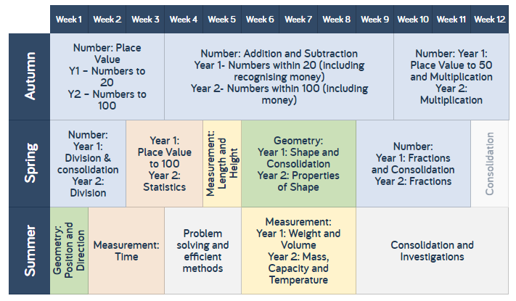

Year 3 and 4

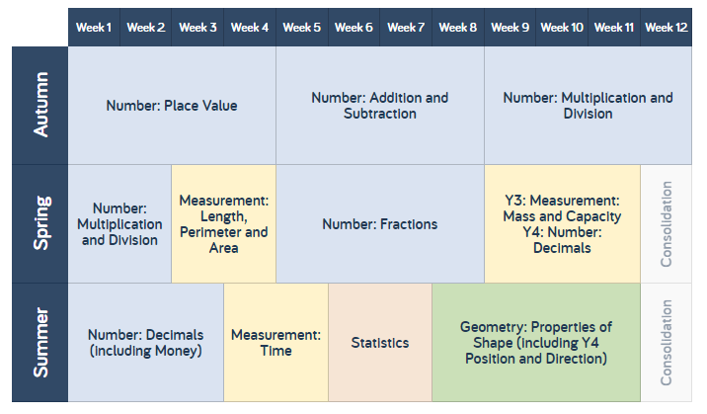

A3

A2

A1

Sp4

Sp3

Sp1

Sp2

S3

S4

S1

S2

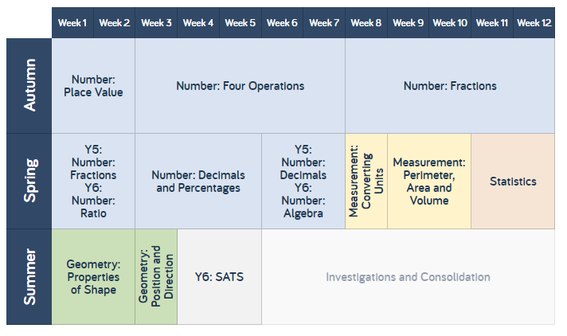Year 5 and 6

S2

S3

S1

Sp21

Sp31

Sp41

Sp51

Sp61

Sp11

A2

A3

A1