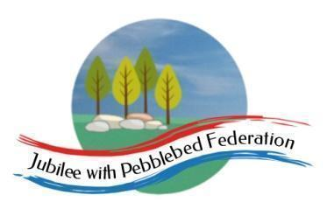

Class 1 Home Learning for the week beginning 3rd May 2021
 | Phonics & Spelling (30 mins) | Reading - This book links with phonics and spelling and will be read for guided reading sessions  (30 mins) | Maths  (30 mins) | Literacy  (30 mins) | PE  (15 minutes)  Leap into Life | Afternoon Work  (45 mins) | Mental Health  Emotions & Feelings
This week’s learning behaviour:
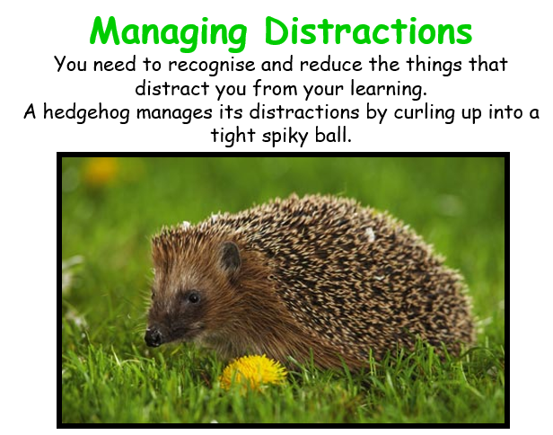
This week Class 1 will be Continuing to think about managing distractions as they work. To be productive in your learning, you sometimes need to recognise and reduce the things that distract you. A hedgehog rolls itself up into a ball tightly. Maybe if we try to be like the hedgehog, we can shut out the parts of the day which prevent us from giving our all to our learning - whatever that may be.

Monday | BANK HOLIDAY
Tuesday | Orange Group  Phase 3  Unit 8  ch  Reception  Phase 3  Unit 11  ear  Year 1  Unit 25  /r/ written as ‘wr’  Year 2  NNS  Block 6 Week 3 | Orange Group  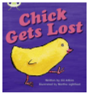  Reception  Year 1  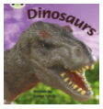  Year 2  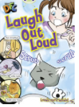 | Orange Group/ Reception  https://www.bbc.co.uk/iplayer/episode/m00029vj/numberblocks-series-3-tween-scenes  Year 1/ Year 2  https://classroom.thenational.academy/lessons/identifying-2-d-shapes-on-the-surfaces-of-3d-shapes-70wk8c | Orange Group/ Reception  https://classroom.thenational.academy/lessons/to-listen-to-and-join-in-with-a-story-6hgpad  Year 1/Year 2  https://classroom.thenational.academy/lessons/to-generate-ideas-for-a-created-story-6hj30r |  | RE  https://www.bbc.co.uk/bitesize/clips/zvhyr82 | Lesson summary: Turn things around
Wednesday | Orange Group  Phase 3  Unit 8  sh  Reception  Phase 3  Unit 11  air  Year 1  Unit 25  /r/ written as ‘wr’  Year 2  NNS  Block 6 Week 3 | Orange Group  Reception  Year 1  Year 2 | Orange Group/ Reception  https://classroom.thenational.academy/lessons/counting-up-to-15-objects-and-putting-them-in-order-part-1-65hkcc  Year 1/ Year 2  https://classroom.thenational.academy/lessons/to-recognise-and-create-repeating-patterns-6rtpac | Orange Group/ Reception  https://classroom.thenational.academy/lessons/to-map-and-speak-the-story-ccrkar  Year 1/Year 2  https://classroom.thenational.academy/lessons/to-tell-a-created-story-from-memory-6xhp8d |  | Science  https://classroom.thenational.academy/lessons/what-is-the-difference-between-deciduous-and-evergre
Thursday | Orange Group  Phase 3  Unit 8  th  Reception  Phase 3  Unit 11  ure  Year 1  Unit 25  /r/ written as ‘wr’  Year 2  NNS  Block 6 Week 3 | Orange Group  Reception  Year 1  Year 2 | Orange Group/ Reception  https://classroom.thenational.academy/lessons/counting-up-to-15-objects-and-putting-them-in-order-part-2-cdj38e  Year 1/ Year 2  https://classroom.thenational.academy/lessons/counting-up-to-15-objects-and-putting-them-in-order-part-3-60v6cc | Orange Group/ Reception  https://classroom.thenational.academy/lessons/to-step-and-speak-the-story-6dh30d  Year 1/Year 2  https://classroom.thenational.academy/lessons/to-explore-problems-that-matter-6mwkgt |  | PSHE  https://classroom.thenational.academy/lessons/stop-look-listen-6rr68e
Friday | Orange Group  Phase 3  Unit 8  ng  Reception  Phase 3  Unit 11  er  Year 1  Unit 25  /r/ written as ‘wr’  Year 2  NNS  Block 6 Week 3 | Orange Group  Reception  Year 1  Year 2 | Orange Group/ Reception  https://classroom.thenational.academy/lessons/to-recognise-and-describe-repeating-patterns-6hjk4c  Year 1/ Year 2  https://classroom.thenational.academy/lessons/to-consolidate-learning-6tgk8r | Geography  Lesson summary: What is a settlement? |  | Geography (links with art)  Lesson summary: Exploring shadows and tone  Music  Jack and the Beanstalk. 2: Jack went to market

Rec done oi
Nnsdone
6 wke 2
1 unit 26
Orange
x

