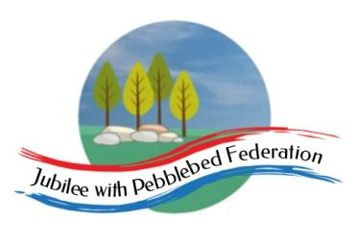

Class 2 Home Learning for the week beginning 7th December
Each Day | Spelling  15 mins |  |  | Grammar  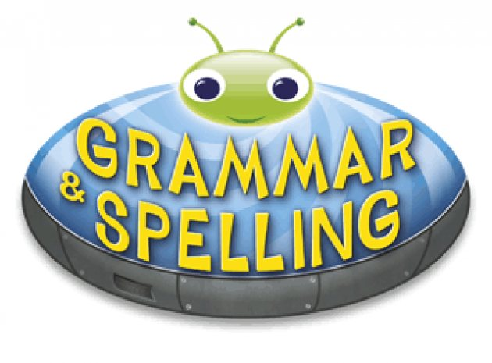  15 mins | Reading  30 mins | Literacy 1 hour  Science 1 hour on Fridays |  | Maths (45 mins) when finished (15 mins)  Please follow the white rose maths links, complete any work on paper at home - do not buy the workbooks.  If your child is off for longer than 14 days - we can arrange for their power maths practise books to be collected.  PE (1 hour on Fridays) |  |  | Afternoon Project  (1 hour)
Monday | Collective Worship  https://www.churchofengland.org/our-faith/faith-home/faith-home-videos/collective-worship-primary-schools-belonging-s2e1 | Literacy Links:  Children normally with Miss Watts and Stella  https://classroom.thenational.academy/lessons/to-make-predictions-ccwk0r  Children normally with Miss Watts and Miss Richards  https://classroom.thenational.academy/lessons/to-write-the-opening-6xk38d |  |  |  |  |  | Maths links for the week:  Children that do maths in the piano room  Week 12 - Number: Multiplication & Division | White Rose Maths  Year 3  Week 11 - Number: Multiplication & Division | White Rose Maths  Year 4  https://whiterosemaths.com/homelearning/year-4/week-11-number-multiplication-division/  Year 5 and Year 6  https://whiterosemaths.com/homelearning/year-6/week-4/ |  |  | RE  Christian Celebrations  https://classroom.thenational.academy/lessons/what-are-the-christian-celebrations-cnjk0d
Tuesday | Collective Worship  https://www.churchofengland.org/our-faith/faith-home/faith-home-videos/collective-worship-primary-schools-loved-s2e2 | Literacy Links:  Children normally with Miss Watts and Stella  https://classroom.thenational.academy/lessons/to-box-up-for-a-purpose-6gukcc  Children normally with Miss Watts and Miss Richards  https://classroom.thenational.academy/lessons/to-practise-speech-with-punctuation-68rp8e |  |  |  |  |  |  |  |  | PSHE  Computer Safety- image sharing  https://drive.google.com/file/d/1FsXNNrFswexsp_DEAcQ4yU9O32AMFZlf/view
Wednesday | Collective Worship  https://www.churchofengland.org/our-faith/faith-home/faith-home-videos/collective-worship-primary-schools-track-s2e3 | Literacy Links:  Children normally with Miss Watts and Stella  https://classroom.thenational.academy/lessons/to-explore-how-a-writer-builds-drama-6nj6cr  Children normally with Miss Watts and Miss Richards  https://classroom.thenational.academy/lessons/to-generate-vocabulary-for-the-build-up-74v62d |  |  |  |  |  |  |  |  | SCIENCE  https://classroom.thenational.academy/lessons/what-is-recycling-and-why-is-it-important-75h3gt
Thursday | Collective Worship  https://www.churchofengland.org/our-faith/faith-home/faith-home-videos/collective-worship-primary-schools-feelings-s2e4 | Literacy Links:  Children normally with Miss Watts and Stella  https://classroom.thenational.academy/lessons/to-write-a-story-with-a-dramatic-middle-part-1-74w68e  Children normally with Miss Watts and Miss Richards  https://classroom.thenational.academy/lessons/to-plan-the-build-up-crw64t |  |  |  |  |  |  |  |  | French  https://www.youtube.com/watch?v=xRsr6wOIhgg  Create a poster of all the French classroom objects you have learnt about.
Friday | Collective Worship  https://www.churchofengland.org/our-faith/faith-home/faith-home-videos/collective-worship-primary-schools-christmas | SCIENCE  https://classroom.thenational.academy/lessons/what-does-it-mean-to-live-sustainably-c4v36d |  |  |  |  |  | PE  Here is a link to some videos a PE company (that Mr R comes from) has made for you.  https://www.youtube.com/channel/UCLNV8D56t6RV0wbsPnbnYeA  https://app.gonoodle.com/ Have a go at some fun dance/workout videos.  If you can: go outside and get some fresh air in the garden! What can you see, hear or smell? |  |  | Mental Health  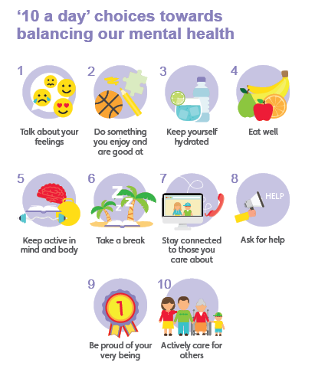  Have you done each of your ‘10 a day’?  Do something which makes you feel good :)

Well done for learning at home this week!

Please email into school anything you are proud of!

Miss Watts :)

