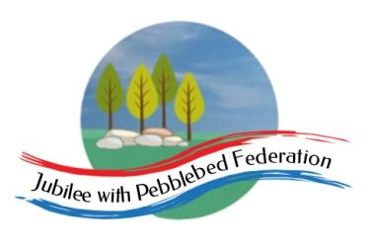

Class 2 Home Learning for the week beginning 14th December
Each Day | Spelling  15 mins |  |  | Grammar  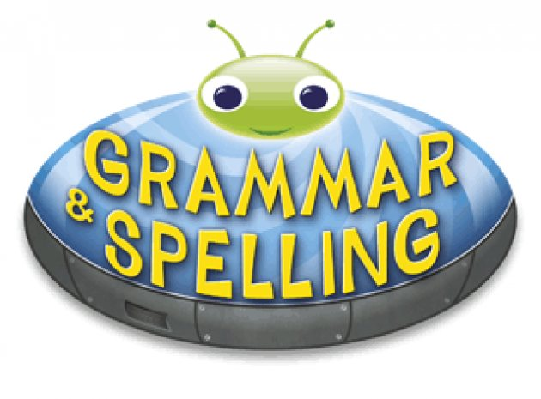  15 mins | Reading  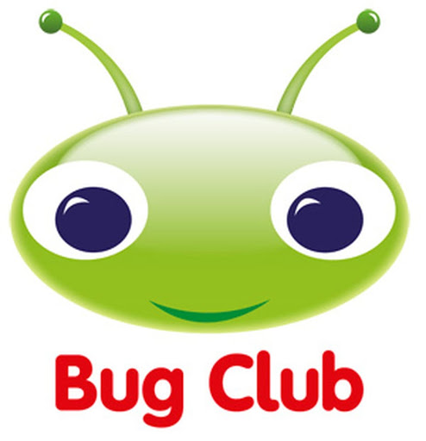  30 mins | Literacy 1 hour  Science 1 hour on Fridays |  | Maths (45 mins) when finished (15 mins)  Please follow the white rose maths links, complete any work on paper at home - do not buy the workbooks.  If your child is off for longer than 14 days - we can arrange for their power maths practise books to be collected.  PE (1 hour on Fridays) |  |  | Afternoon Project  (1 hour)
Monday | Collective Worship  https://www.churchofengland.org/our-faith/faith-home/faith-home-videos/collective-worship-primary-schools-advent | Escape from Pompeii  In school we will be finishing writing up our stories inspired by the Escape from Pompeii story we have read.  Write your story and read it aloud to your family! Remember it is an adventure story so it should be exciting and descriptive! |  |  |  |  |  | Maths links for the week (Just 3 days this week):  Children that do maths in the piano room  Week 12 - Number: Multiplication & Division | White Rose Maths  Year 3  https://whiterosemaths.com/homelearning/year-3/week-12-number-multiplication-division/  Year 4  https://whiterosemaths.com/homelearning/year-4-/week 12  Year 5 and Year 6  https://whiterosemaths.com/homelearning/year-6/week-4/  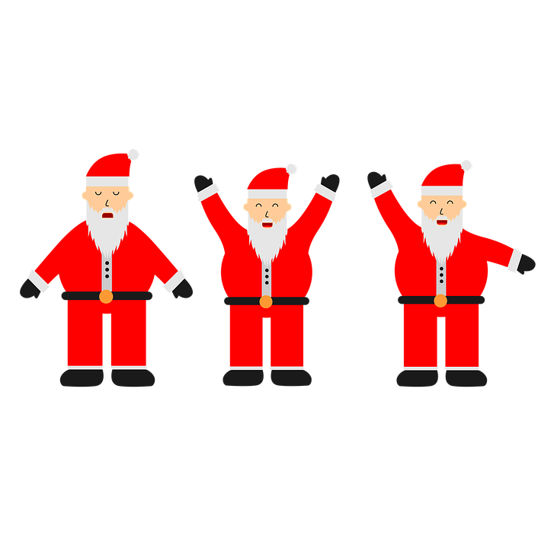  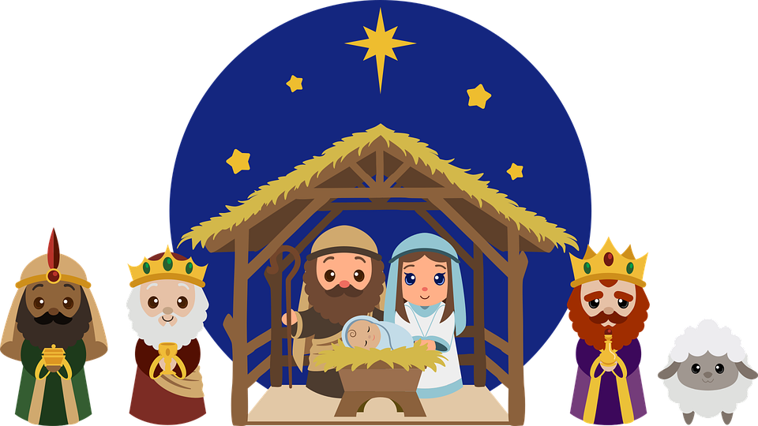 |  |  | CHRISTMAS WINDOW COMPETITION  At school, we are entering the Parish Christmas window competition. Have a go at decorating a window in your house. Perhaps using paper snowflakes or pretty lights. Ask a grownup for help!
Tuesday | Collective Worship  https://www.churchofengland.org/our-faith/faith-home/faith-home-videos/collective-worship-primary-schools-christmas | Christmas Writing!  https://minds-in-bloom.com/20-christmas-writing-prompts/  Choose one of the prompts to do some Christmas themed writing today. |  |  |  |  |  |  |  |  | CHRISTMAS CRAFTS  https://www.countryliving.com/diy-crafts/g5030/christmas-crafts-for-kids/  On this website are a range of Christmas craft activities for children.  Choose one you’d like to do. Ask a grownup for help!  Whilst you are making your Christmas creation, maybe you could listen to some Christmas music to get you in the festive mood!  Have fun :)
Wednesday | Collective Worship  https://www.youtube.com/watch?v=FrTFAZPQxpE | Christmas Writing!  https://minds-in-bloom.com/20-christmas-writing-prompts/  Choose one of the prompts to do some Christmas themed writing today.
Thursday | Collective Worship  https://www.youtube.com/watch?v=Juv2c0xgGno | Christmas Santa Run  Today we are doing the Santa run for ELF (Exeter Leukemia Fund) at school.  So put on your best outfit and do as many laps of your garden as you can! Or, if not have a go at this Christmas themed workout instead.  https://www.youtube.com/watch?v=snS4l_edWpk
Friday | Collective Worship  https://www.youtube.com/watch?v=QJntbYytPz8 | Science  https://www.science-sparks.com/wp-content/uploads/2020/10/Christmas-Science-New-2020.pdf  Attached is a link to some fun Christmas themed science experiments that you could try at home!  Have fun! |  |  |  |  |  | PE  Here is a link to some videos a PE company (that Mr R comes from) has made for you.  https://www.youtube.com/channel/UCLNV8D56t6RV0wbsPnbnYeA  https://app.gonoodle.com/ Have a go at some fun dance/workout videos.  If you can: go outside and get some fresh air in the garden! What can you see, hear or smell? |  |  | Mental Health  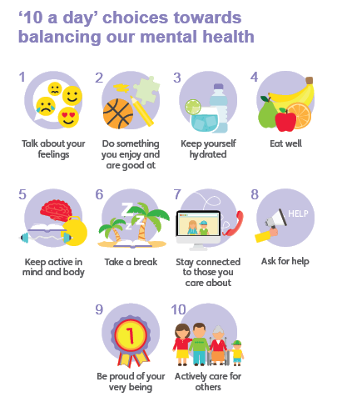  Have you done each of your ‘10 a day’?  Do something which makes you feel good :)

Well done for learning at home this week!

