Class 1 Home Learning for the week beginning 22nd March 2021
 | Phonics & Spelling (30 mins)  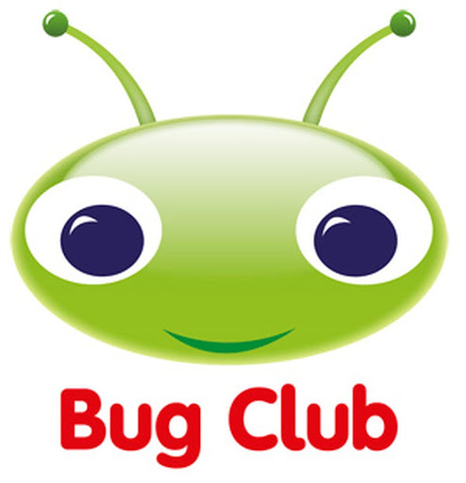 | Reading - This book links with phonics and spelling and will be read for guided reading sessions  (30 mins) | Maths  (30 mins) | Literacy  (30 mins) | PE  (15 minutes)  Leap into Life | Afternoon Work  (45 mins) | Mental Health  Emotions & Feelings
This week’s learning behaviour:
This week we will be thinking about revising your learning. You need to be flexible and able to change and adapt your plans if they are not working. Think about your learning as you are doing it. Review it - what is working well? What is not working well?
When an American sea otter is unable to open a clam it finds two stones and puts one on its tummy then the clam on top and then it bashes it with the second stone. It is then able to eat the clam.
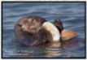
Monday | Orange Group  Phase 3  Unit 6  j  Reception  Phase 3  Unit 8  ng as ng  Year 1  Unit 14  ai as a-e  Year 2  Commas in a list  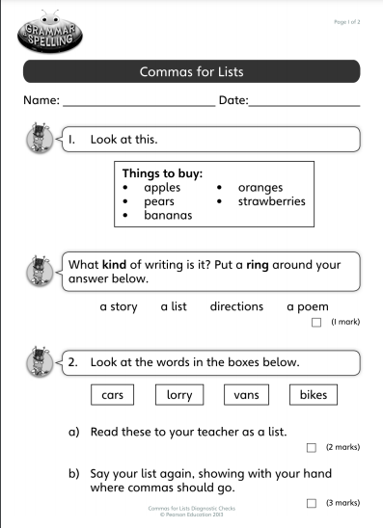 | Orange Group  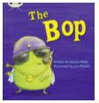  Reception  Making Muffins today  Year 1  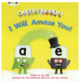  Year 2  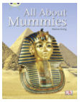 | Orange Group/ Reception  https://classroom.thenational.academy/lessons/combining-two-groups-71gkec  Year 1  PUMA TEST today  Year 2  I can create a pictogram where 1 picture means 1 thing | Orange Group/Reception  Play Simon Says  Year 1/Year 2  You will be given a set of instructions and correct any errors, considering spelling, grammar and punctuation. |  | History/Georaphy  The Extinction of the Dinosaurs  https://classroom.thenational.academy/lessons/combining-2-quantities-to-find-the-totals-6mr3jr | Starving the Anxiety Gremlin  Chapter 2  Let’s Meet a Mystery Creature
Tuesday | Orange Group  Phase 3  Unit 6  v  Reception  Phase 3  Unit 8  th as th  Year 1  Phase 5  Unit 15  ee as e-e  Year 2  Bug Club video and games for commas in a list. | Orange Group  Reception  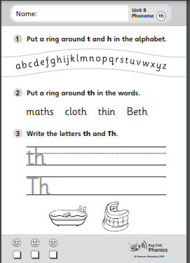  Year 1  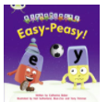  Year 2 | Orange Group/ Reception  https://classroom.thenational.academy/lessons/combining-two-groups-including-zero-ccw6ad  Year 1  I can partition 2 digit numbers  Year 2  PUMA TEST today | Orange Group/ Reception  PIRA test today  Draw pictures for instructions on how to put your coat and wellies on to go outside  Year 1/ Year 2  Y1 - PIRA test today  Y2 - You will be improving your elicitation instructions today using a purple polishing pen to work on spelling and punctuation. |  | Science  https://www.bbc.co.uk/teach/class-clips-video/teeth/zr8ygwx | Chapter 3  Let’s Learn about Feelings!
Wednesday | Orange Group  Phase 3  Unit 6  w  Reception  Phase 5  Unit 9  oo as oo (short)  Year 1  Unit 5  Phase 16  igh as i-e  Year 2  Pick a paragraph out of the bok and copy it neatly into your handwriting book | Orange Group  Reception  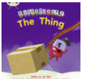  Year 1  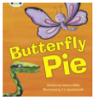  Year 2 | Orange Group/ Reception  https://classroom.thenational.academy/lessons/using-manipulatives-to-count-on-when-adding-60vpat  Year 1  I can partition 2 digit numbers  Year 2  I can interpret 1:1 pictograms | Orange Group/ Reception  Read ‘Dear Zoo’. Now talk to your adult to choose which pet you might want to look after. What instructions might be needed to do this?  Year 1/ Year 2  Y1 - working with reception (see above)  Y2  PIRA TEST today |  | Art  https://www.bbc.co.uk/teach/class-clips-video/art-and-design-ks1-ks2-creating-a-collage-landscape/zfrfbdm | Chapter 4  What is Anxiety?
Thursday | Orange Group  Phase 3  Unit 6  x  Reception  Phase 5  Unit 9  Language Session  Year 1  Unit 5  Phase 17  oa as o-e  Year 2  Bug Club, Spelling Shed | Orange Group  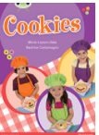  Reception  Year 1  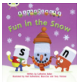  Year 2  Interference with CS | Orange Group/ Reception  https://classroom.thenational.academy/lessons/adding-two-numbers-using-a-number-track-to-count-on-cmvk0t  Year 1  I can partition 2 digit numbers.  Year 2  I can create pictograms using one picture to represent 2,5 or 10 | Orange Group/ Reception  Act out their instructions using props to help them.  Year 1/Year 2  Map out your instructions for looking after your choice of pet from the Dear Zoo book. |  | RE  https://www.bbc.co.uk/bitesize/clips/zjgkq6f  https://www.bbc.co.uk/bitesize/topics/ztkxpv4/articles/z4t6rj6 | Chapter 5  Things we get anxious about
Friday | Orange Group  Phase 3  Unit 6  Language Session and assessment of sounds  Reception  Phase 5  Unit 9  Language Session - recap  Year 1  Phase 5  Unit 18  oo written as u-e  Year 2  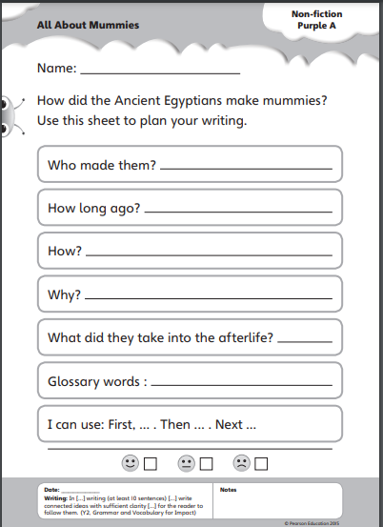 | Orange Group  Reception  Year 1  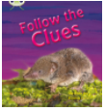  Year 2  Inference with CS | Orange Group/ Reception  https://classroom.thenational.academy/lessons/combining-2-quantities-to-find-the-totals-6mr3jr  Year 1  I can partition numbers in different ways  Year 2  I can interpret pictograms where 1 picture equals 2,5 or 10. | Orange Group/ Reception  Give someone else instructions to make a sandwich.  Year 1/Year 2  Practise writing humorous questions to begin your instructions to look after your chosen pet. |  | PSHE  https://schools.1decision.co.uk/info/videos-5-8/worry-video-scorm/index.html

