13th January 2023

Dear Parents,

An exhilarating term ended with a lovely Christmas Show in Broadhembury Church. Despite the challenge of so many illnesses, the children put on a great performance and it was wonderful for the school community to come together in this festive celebration. We were very proud of them.

The last few weeks of term were extremely productive and busy, with many highlights. Our older Key Stage 2 children took part in an athletics competition at Honiton Community College; Class 1 had an afternoon of Christmas activities showcasing work for parents; Children enjoyed Christingle making and taking part in the service in the church and the children sang beautifully at the village hall for the over 60’s enjoying their Christmas meal. They sang beautifully and made lots of people smile.

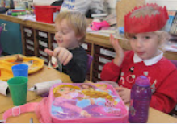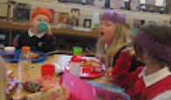

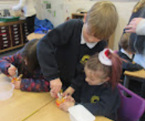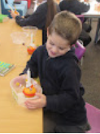

A huge thank you to all who attended the Class 1 Christmas Afternoon - it was a great success. The children were really proud to show you the work that they had completed during the Autumn Term and it was lovely to see them completing the Christmas Activities with you all. They were keen to chat about what they had learnt.

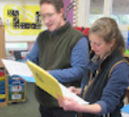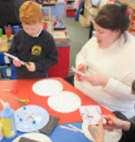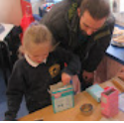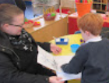
Thank you all for your continued support.
God bless and have a lovely weekend.
Best wishes from Katie Gray and the staff at Broadhembury CE School
?

?

Talking about Learning
When your child has had chance to process the day and is calm, maybe at dinner time. Please can you talk to your child about their learning. This could be done by asking what they have learnt? What lessons have you done today? What is the most interesting thing you’ve learnt? etc. In school we are working on the children being able to talk about their learning, retrieve information they have learnt and explain their thinking. The more practise they have at this the more it will help them. Thank you for your help with this, and they may share with you some of the great things they are doing each day.

BROADHEMBURY BRIDGES

Well done to the children who achieved a Broadhembury Bridge Award. Your learning behaviours have been exemplary.

Lexi - for inspiring achievement and effort at the HCC Athletics Event.

Lettie – for exceptional academic progress.

Question of the month

Do New Year resolutions really work?

Key Dates – Spring Term 2023
Tuesday 24th January- Year 5 and 6 Girls Futsal at Honiton Community College.
13th – 19th February - Half term.
Friday 31st March- End of term.

Reminders:
Recycling
Please could you send in any recycling for the children to use in our making area. Things like plastic bottles, cardboard boxes, kitchen roll holders etc. would be great! Thank you.

School Uniform
Please can you ensure that your child has all their uniform named. It really helps at the end of the day to ensure that the correct jumper is returned to the correct child. Also, as the weather gets colder, please can you ensure that your child has a warm coat and that any hats, gloves etc. are named. Thank you for your help.

School Bus
We have had a request from the bus company who brings the children to school from Dunkeswell, please can parents not park in the bus stop to enable the bus to be able to park and the children to get off the bus safely. Thank you for your cooperation.

Toys
Please can we request that the children do not bring in toys or stickers from home? These often get lost or damaged and cause distractions for the children during the day. Thank you.

Free School Meals
If your circumstances have recently changed your child may have become eligible for free school meals. This will also bring extra funding to the school, which will be used to help your child. For an instant decision or to learn more please go online at https://www.devon.gov.uk/educationandfamilies/school-information/school-meals.

Sharing Assembly
Sharing assembly will continue each Friday afternoon at 3pm. All parents/carers are invited to come and see the children sharing their learning.

Wellbeing
There has been much press in recent months about children’s mental health. As part of our drive to support this we are going to include something each month in the newsletter about Health and Wellbeing. We hope you find this section useful. If you have any topics you would like us to find some helpful tips about, please let us know.

After the Christmas break it has been lovely to see the children return to school. However, for some children, returning to school can be a worrying time, full of uncertainty and anxiety. As a parent, you always want to do the best to reassure your child and to ease their worries. Dr Barnardo's have developed some coping strategies to support children if this is a difficult time.
https://www.barnardos.org.uk/support-hub/back-school-strategies-coping-feelings
Back to school: Strategies for coping with feelings | Barnardo's

Grounding techniques. A grounding technique is a coping strategy for managing intense feelings and emotions. These techniques help to ‘ground’ us, which means they help us to notice the present moment we are in.
www.barnardos.org.uk

Collective Worship Activity
This term we will be focussing in school on the value of Perseverance. We hope your family will find these ideas helpful as you explore the value and have fun together. If the children bring back something that you have done at home linked to the Collective Worship activity, or can talk about a discussion they’ve had at home linked to it, then Mrs Gray will award them with a new special sticker.
