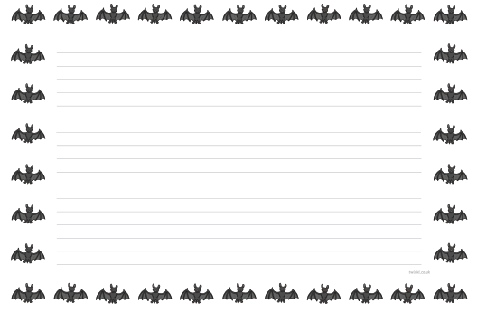

Why might Broadhembury be a good place to find bats?

How do bats raise their young?

Where do bats live?

What do bats eat?

Bats