Fun home activities
w/c 27.04.20
Theme: Games
Monday | 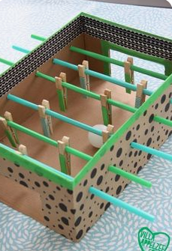Can you make a table football this week? You can use whatever you can find to make it. Don’t take pegs from the peg basket without checking with your grown ups first. Any cardboard box will do and you could use sticks or twigs and a scrunched up piece of paper for the ball. See how creative you can be.
Tuesday | 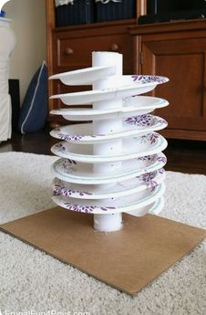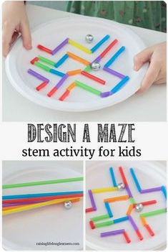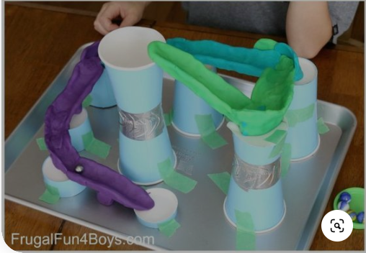Have a go at making a marble run. These are just some ideas, but you could use anything that you have available to you at home.
Wednesday | 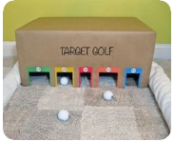Today, make your own golf course. It doesn’t matter if you don’t have a golf club - you could use anything (an umbrella, broom handle?) If you don’t have a golf ball, what else could you use? Be creative but make sure that you ask your grown up before you take anything.
Thursday | 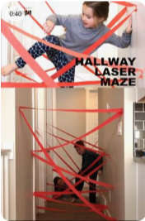This looks like great fun but make sure that you don’t stick anything to the walls without checking with your grown-up.
Friday | 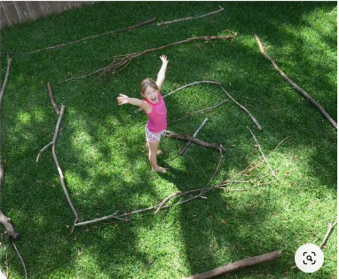If you have a garden at home, have a go at making a maze - no cheating! If you don’t have a garden, see if you can make a ‘mini maze in a box’

