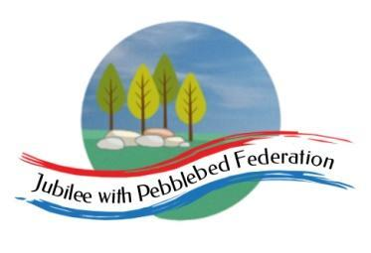

Class 2 Home Learning
For activities in purple, please visit google classroom where you will find specific work related to each subject to complete and ‘turn in’.
Timings | 15 mins | 30 mins | 15 mins | 15 mins | 1 Hour | 1 Hour | 1 Hour
Monday | https://www.edshed.com/en-gb/login | Reading  https://www.activelearnprimary.co.uk/login?c=0 | https://ttrockstars.com/ | 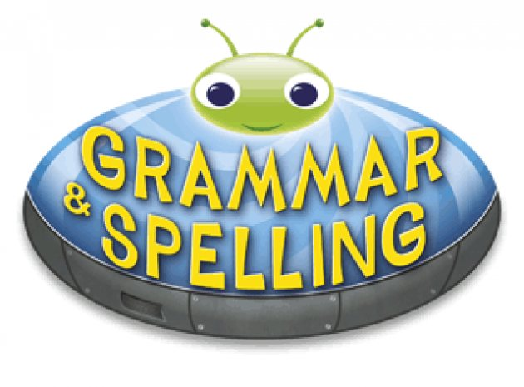  https://www.activelearnprimary.co.uk/login?c=0 | Maths  Follow the link for your year group for videos in the most current week. Then complete the worksheet provided on google classroom.  Children that do maths in the piano room  https://whiterosemaths.com/homelearning/year-2/  Year 3  https://whiterosemaths.com/homelearning/year-3/  Year 4  https://whiterosemaths.com/homelearning/year-4/  Year 5/6  https://whiterosemaths.com/homelearning/year-5/ | Literacy  Write a persuasive report or debate speech about an area of environmental concern.  Are humans harming the planet? | RE  Easter  Why do Christians Call the Day Jesus Died ‘Good Friday’?  https://www.topmarks.co.uk/Easter/GoodFriday.aspx
Tuesday | https://www.edshed.com/en-gb/login | https://www.activelearnprimary.co.uk/login?c=0 | https://ttrockstars.com | https://www.activelearnprimary.co.uk/login?c=0 | Maths  Follow the link for your year group for videos in the most current week. Then complete the worksheet provided on google classroom.  Children that do maths in the piano room  https://whiterosemaths.com/homelearning/year-2/  Year 3  https://whiterosemaths.com/homelearning/year-3/  Year 4  https://whiterosemaths.com/homelearning/year-4/  Year 5/6  https://whiterosemaths.com/homelearning/year-5/ | Literacy  Easter Writing  As we have been doing story writing in literacy this term. I would like you to retell one of the greatest stories of all time!  Retell the story of Palm Sunday, Good Friday and Easter Sunday.  Use the skills we have been learning about to describe characters, settings and events in detail.  https://www.bbc.co.uk/teach/class-clips-video/religious-studies-ks2-easter/znkngwx | Science  L.O To understand how mammals reproduce.  https://www.bbc.co.uk/bitesize/topics/zgssgk7/articles/z9xb39q  How do animals reproduce?  https://www.bbc.co.uk/bitesize/topics/zgssgk7/articles/z2msv4j  Human life cycle
Wednesday | https://www.edshed.com/en-gb/login | https://www.activelearnprimary.co.uk/login?c=0 | https://ttrockstars.com | https://www.activelearnprimary.co.uk/login?c=0 | Maths  Follow the link for your year group for videos in the most current week. Then complete the worksheet provided on google classroom.  Children that do maths in the piano room  https://whiterosemaths.com/homelearning/year-2/  Year 3  https://whiterosemaths.com/homelearning/year-3/  Year 4  https://whiterosemaths.com/homelearning/year-4/  Year 5/6  https://whiterosemaths.com/homelearning/year-5/ | Literacy  Easter Writing  As we have been doing story writing in literacy this term. I would like you to retell one of the greatest stories of all time!  Retell the story of Palm Sunday, Good Friday and Easter Sunday.  Use the skills we have been learning about to describe characters, settings and events in detail.  https://www.bbc.co.uk/teach/class-clips-video/religious-studies-ks2-easter/znkngwx | https://classroom.thenational.academy/lessons/reduce-reuse-recycle-crt38c
Thursday | https://www.edshed.com/en-gb/login | https://www.activelearnprimary.co.uk/login?c=0 | https://ttrockstars.com | https://www.activelearnprimary.co.uk/login?c=0 | Maths  Follow the link for your year group for videos in the most current week. Then complete the worksheet provided on google classroom.  Children that do maths in the piano room  https://whiterosemaths.com/homelearning/year-2/  Year 3  https://whiterosemaths.com/homelearning/year-3/  Year 4  https://whiterosemaths.com/homelearning/year-4/  Year 5/6  https://whiterosemaths.com/homelearning/year-5/ | Easter Egg Hunt!  Today we are having an Easter Egg Hunt at school!  Maybe you can have one in your garden!  Have a wonderful Easter holidays! | PE  Premier sports have made some videos for you to follow at home for PE.  https://www.youtube.com/channel/UCLNV8D56t6RV0wbsPnbnYeA  Please do any of the ball skills on their channel.  You could also go out in the garden and get some fresh air or go for a walk with a grownup.  There are also some great videos to do on https://www.bbc.co.uk/teach/supermovers

