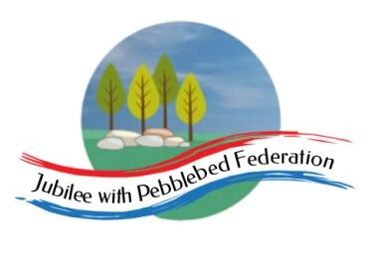

Class 2 Weekly Home Learning Timetable 18.1.21
Timings | 30 mins | 1 hour (45 mins then 15 mins TT) | 1 hour | 1 hour | 15 mins | 30 mins | 15 mins | 20 mins
Monday  Learning behaviour animal of the day  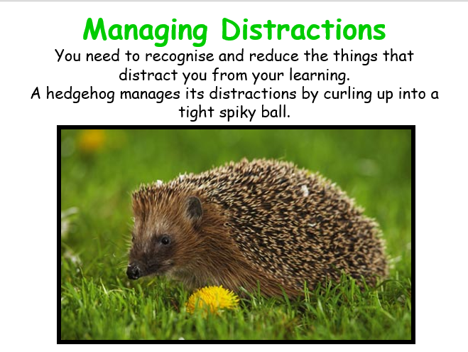  10 a day mental health of the day  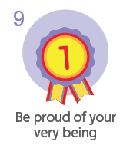 | Daily Dashboard and Collective Worship  PPT on GC | Piano Room Children  No video today.  Practice questions on grouping and sharing on google classroom.  Year 4  No video today.  Google classroom sheet to complete - independently. I would like to know what you know about area already. We will re-do this sheet on Thursday after 3 lessons.  Year 5/6  No video today.  Normally in school, at the end of multiplication and division unit we would do an assessment.  Have a go at the blue sheet on google classroom. | Piano Room Children  L.O. To understand how what character’s say can tell us about their personality.  Today we will look through the speech in the book and play a guessing game to decide which character it is.  Google classroom sheet to do.  Everyone else  L.O - To understand how Hiccup’s character changes throughout the story.  Now that we have read/heard the whole book, we can think about How Hiccup has changed throughout the story.  Google classroom sheet to do. | RE  To understand why the 10 commandments were created.  What were the 10 commandments? Think back to our last lesson, who made them? What do you think people were doing which meant they needed to be created.  Watch this https://www.bbc.co.uk/bitesize/clips/ztd2hyc  Google classroom sheet to do. | Bug Club Grammar | Bug Club reading with  Quiz | Spelling | Read a book or listen to Miss Watts reading How to Train Your Dragon
Tuesday  Learning behaviour animal of the day  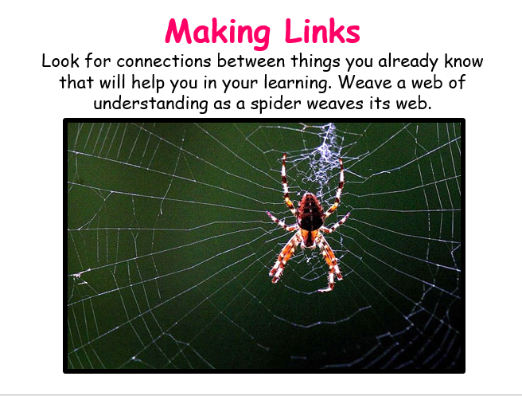  10 a day mental health of the day | Daily Dashboard and Collective Worship  PPT on GC | Piano Room Children  To divide by 2.  https://whiterosemaths.com/homelearning/year-2/ Spring week 3 - Watch this link  Sheet on google classroom to complete.  2B pg 16  Year 4  To understand the area and use counting squares to help us.  https://classroom.thenational.academy/lessons/understand-that-area-is-a-measure-of-surface-and-is-measured-in-square-units-part-1-ccwk2c  Sheet on google classroom to complete.  4B pg 72-79  Year 5/6  Today we start fractions! Have a go at the elicitation sheet on google classroom - I would like to know what you remember about fractions. | Piano Room Children  L.O. To write what they think some of the characters might say.  Today we will focus on some other characters in the story who don’t speak. We will decide what we think they would have said and write speech bubbles.  Google classroom sheet to do.  Everyone else  L.O. To practise correctly punctuated dialogue.  Today we will look at characters speaking in the book and learn how to punctuate the speech correctly. We will also look at more exciting words to use other than said.  Google classroom sheet to do. | Topic - Computing  To create a google slides presentation containing pictures and information of Anglo Saxon artefacts.  Use the web to find and download images showing a range of Anglo-Saxon artefacts.  Yr 3/4 - add labels explaining what each artefact is.  Yr 5/6 - write a small paragraph explaining what the artefact is, what it is made of and how it was used in everyday life.  INCLUDE AT LEAST ONE SLIDE OF ARTEFACTS FOUND IN EXETER.  THIS PIECE OF WORK WILL BE DUE TOMORROW AT 4.30PM SO YOU HAVE TWO LESSONS TO DO IT. | Bug Club Grammar | Bug Club reading with  Quiz | Spelling | Read a book or listen to Miss Watts reading How to Train Your Dragon
Wednesday  Learning behaviour animal of the day  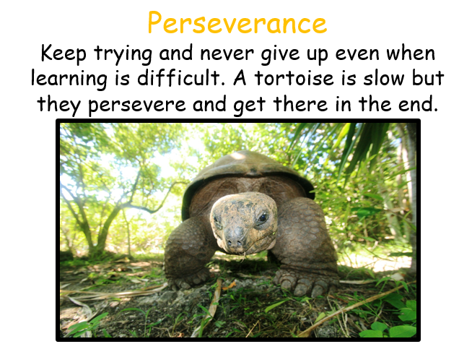  10 a day mental health of the day  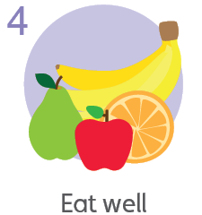 | Daily Dashboard and Collective Worship  PPT on GC | Piano Room Children  To sort odd and even numbers.  https://whiterosemaths.com/homelearning/year-2/ Spring week 3 - Watch this link  Sheet on google classroom to complete.  2B pg 20  Year 4  To make shapes using of area.  https://classroom.thenational.academy/lessons/understand-that-area-is-a-measure-of-surface-and-is-measured-in-square-units-part-2-6xj3cc  Sheet on google classroom to complete.  4B pg 84  Year 5/6  To understand equivalent fractions.  Watch this https://whiterosemaths.com/homelearning/year-6/week-8-number-fractions/ on equivalent fractions.  Google classroom sheet to complete.  5B pg 56 | Piano Room Children  L.O. To use verbs and the suffix -ly to describe character’s actions.  Today we will look through the book and find verbs. We will add -ly words to better describe the character’s actions.  Google classroom sheet to do.  Everyone else  L.O. To explore how modal verbs in the story.  Modal verbs e.g can, must, could, should, will etc can tell us how a character is feeling or what they are like.  Today we will explore modal verbs in How to Train Your Dragon.  Google classroom sheet to do. | Topic - Computing  To create a google slides presentation containing pictures and information of Anglo Saxon artefacts.  Carry on with yesterday’s computing task. | Bug Club Grammar | Bug Club reading with  Quiz | Spelling | Read a book or listen to Miss Watts reading How to Train Your Dragon
Thursday  Learning behaviour animal of the day  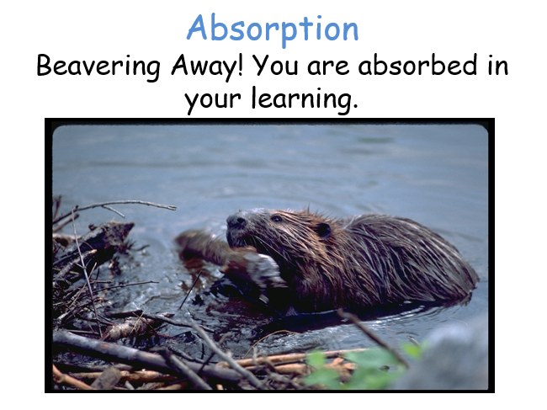  10 a day mental health of the day  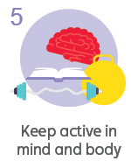 | Daily Dashboard and Collective Worship  PPT on GC | Piano Room Children  To divide by 5.  https://whiterosemaths.com/homelearning/year-2/ Spring week 3 - Watch this link  Sheet on google classroom to complete.  2B pg 24  Year 4  To compare area.  https://classroom.thenational.academy/lessons/calculate-and-compare-the-area-of-rectangles-using-square-centimetres-cm-69h6cd  Sheet on google classroom to complete.  4B pg 88  Year 5/6  To simplify fractions.  https://whiterosemaths.com/homelearning/year-6/week-8-number-fractions/ simplify fractions  Google classroom sheet to complete.  6A pg 124 | Piano Room Children  L.O. To use and, but or because to extend sentences.  Today we will choose sentences from the story and improve them using and, but or so.  Google classroom sheet to do.  Everyone else  L.O. To understand the structure of the story.  Today we will use a text structure chart to understand the story’s order and key events.  Google classroom sheet to do. | PE  Premier sports have made some videos for you to follow at home for PE.  https://www.youtube.com/channel/UCLNV8D56t6RV0wbsPnbnYeA  You could also go out in the garden and get some fresh air or go for a walk with a grownup.  Don’t forget gonoodle for some fun workout videos too! | Bug Club Grammar | Bug Club reading with  Quiz | Spelling | Read a book or listen to Miss Watts reading How to Train Your Dragon
Friday  Learning behaviour animal of the day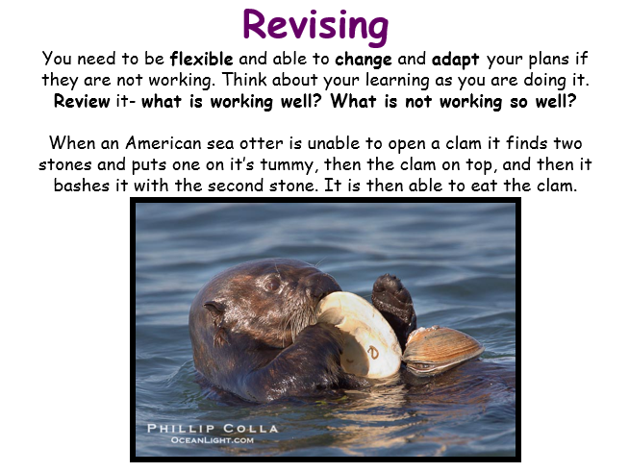 | Daily Dashboard and Collective Worship  PPT on GC | Science  To understand what classification means and how classification keys can be used to group animals into 6 main groups.  Watch powerpoint slides 1-7 on google classroom.  Complete google classroom sheet.  10 a day mental health of the day | French - 30 mins  Go to this link  https://www.bbc.co.uk/bitesize/topics/zjcbrj6/articles/zcqsxbk  Google classroom sheet to complete.  TT Rockstars - 30 mins | PSHE 30 mins  Today we will look at ‘Enterprise’  What does this word mean?  How about budget? What does this mean?  Google classroom sheet to complete.  Bug Club reading with  Quiz 30 mins | Bug Club Grammar | Bug Club reading with  Quiz | Spelling | Read a book or listen to Miss Watts reading How to Train Your Dragon

