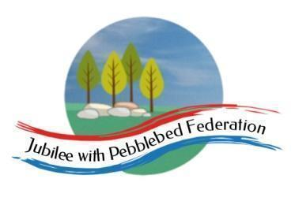

Class 1 Home Learning for the week beginning 17th May 2021
 | Phonics & Spelling (30 mins)  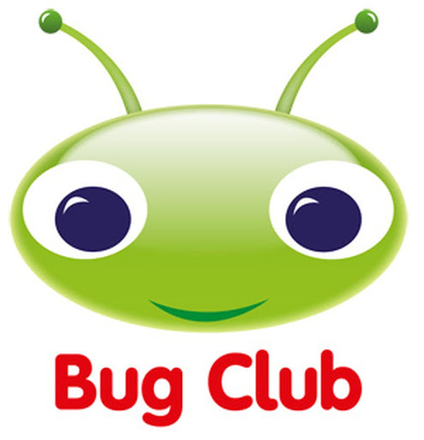 | Reading - This book links with phonics and spelling and will be read for guided reading sessions  (30 mins) | Maths  (30 mins) | Literacy  (30 mins) | PE  (15 minutes)  Leap into Life | Afternoon Work  (45 mins) | Mental Health  Emotions & Feelings
This week’s learning behaviour:
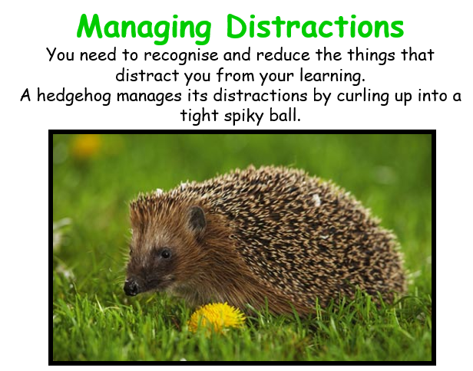
This week Class 1 will be continuing to think about managing distractions as they work. To be productive in your learning, you sometimes need to recognise and reduce the things that distract you. A hedgehog rolls itself up into a ball tightly. Maybe if we try to be like the hedgehog, we can shut out the parts of the day which prevent us from giving our all to our learning - whatever that may be.

Monday | Orange Group  Phase 2  Unit 9/oo/ as ‘oo’  Reception  Phase 3  End of Phase Assessments all this week.  Y1  Unit 27  ch as tch  Y2  NNS  Block 6 Week 5 | Orange Group  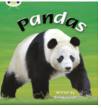  Reception  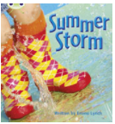  Y1  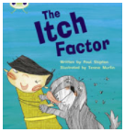  Y2  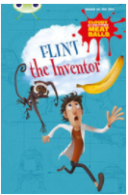 | Orange Group/ Reception  https://www.bbc.co.uk/iplayer/episode/m000t2pb/numberblocks-series-5-whats-my-number  Y1/ Y2  https://classroom.thenational.academy/lessons/to-find-half-of-a-quantity-6nhpct | Orange Group  Reception  Y1  Y2  FOR ALL GROUPS TODAY I WILL PUT THE STORY MAP ONTO GOOGLE CLASSROOM. | Physical Education KS1 / KS2: Simple Indoor Track and Field Challenges | RE  https://www.bbc.co.uk/bitesize/clips/z934wmn  Music  Jack and the Beanstalk. 5: Fee-fi-fo-fum! | Lesson summary: Keep calm and carry on
Tuesday | Orange Group  Phase 2  Unit 9  /oo/ as ‘oo’ (short)  Reception  End of Phase Assessments all this week.  Y1  Unit 27  alternatives for sh  Y2  NNS  Block 6 Week 5 | Orange Group  Reception  Y1  Y2 | Orange Group/ Reception  https://www.bbc.co.uk/cbeebies/watch/numberblocks-drawing-numbers  Y1/ Y2  https://maestro.cornerstoneseducation.co.uk/project/y1-wrm-summer-2021/lesson/68908 - Find a half (1) upload slides to Google Classroom | Orange Group/ Reception  Draw your favourite character from the book. What might they be saying? Write it in a speech bubble?  Y1/Y2  https://www.bbc.co.uk/bitesize/clips/zvftsbk |  | Science  https://classroom.thenational.academy/lessons/what-changes-occur-to-a-tomato-plant-6cv6cr
Wednesday | Orange Group  Phase 2  Unit 9  Language session  Reception  End of Phase Assessments all this week.  Y1  Unit 27  e as ea  Y2  NNS  Block 6 Week 5 | Orange Group  Reception  Y1  Y2 | Orange Group/ Reception  https://www.bbc.co.uk/cbeebies/watch/numberblocks-days-of-spring-song  Y1/ Y2  https://maestro.cornerstoneseducation.co.uk/project/y1-wrm-summer-2021/lesson/68908 Find a half (2) upload slides to Google Classroom | Orange Group/ Reception  Listen to the story of ‘The Disgusting Sandwich again today’ - can you design your own disgusting sandwich?  Y1/ Y2  https://www.bbc.co.uk/bitesize/topics/zvwwxnb/articles/ztcp97h |  | Geography  Lesson 3 What affects where people live? 23m video
Thursday | Orange Group  Phase 2  Unit 9  Assessment  Reception  End of Phase Assessments all this week.  Y1  Unit 27  /w/ /o/ as wa  Y2  NNS  Handwriting | Orange Group  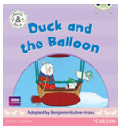  Reception  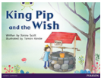  See Guided Reading Notes  Y1  See Guided Reading Notes  Y2 | Orange Group/ Reception  https://www.bbc.co.uk/cbeebies/watch/numberblocks-find-your-ten-friends  Y1/ Y2  https://classroom.thenational.academy/lessons/to-find-one-quarter-of-a-shape-c8r66c | Orange Group  Reception  Y1/ Y2  https://www.bbc.co.uk/bitesize/topics/zwwp8mn/articles/z3nfw6f |  | PSHE  Tying shoelaces - I will upload One Decision film  https://www.bbc.co.uk/bitesize/articles/zvxj47h
Friday | Orange Group  Phase 2  Unit 9  Recap  Reception  End of Phase Assessments all this week.  Y1  Unit 27  /u/ written as ‘o’  Y2  NNS  Handwriting | Orange Group  Reception  See Guided Reading Notes  Y1  See Guided Reading Notes  Y2  PCM | Orange Group/ Reception  https://www.bbc.co.uk/iplayer/episode/b08q4jkq/numberblocks-series-2-double-trouble  Y1/ Y2  https://classroom.thenational.academy/lessons/to-find-one-quarter-of-a-quantity-6xjkad | Orange Group/ Reception/ Y1/ Y2  https://www.bbc.co.uk/bitesize/clips/z8mn34j  I will upload the sheet to be completed. |  | Art  https://www.tate.org.uk/kids/explore/who-is/who-georgia-okeeffe

