Fun home activities
w/c 20.04.20
Theme: Flowers
Monday | 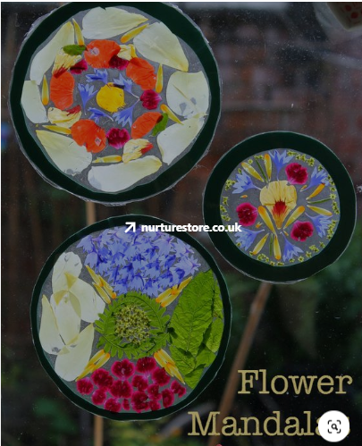A mandala is a geometric arrangement. In various spiritual traditions, mandalas are used for focusing attention, as a spiritual guidance tool, and as an aid to meditation  .Make a flower Mandala out of petals stuck to a piece of clear plastic. You could use the bottom of a cylindrical drinks bottle or cut out a shape from a clear plastic food carton (not raw meat). Ask your adult to help you with the cutting. If you have some card or coloured paper, you could make a frame first. Then, arrange flower petals (don’t pick them without checking with your grown-ups) into a pattern on your shape and glue them down. Thread some cotton, wool, string, whatever you have through and hang your mandala up at the window.  .  If you are doing this in school, then cut a circle of black card and place on a laminating pouch. Make your arrangement of petals and leaves. Fold over and laminate.
Tuesday | 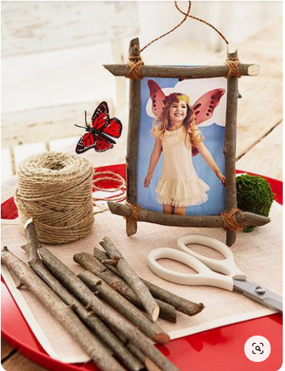Make a photograph frame out of sticks and string. Can you look carefully at how to lash the sticks together using a figure of eight movement? See if you can find a photograph to put into your frame.
Wednesday | 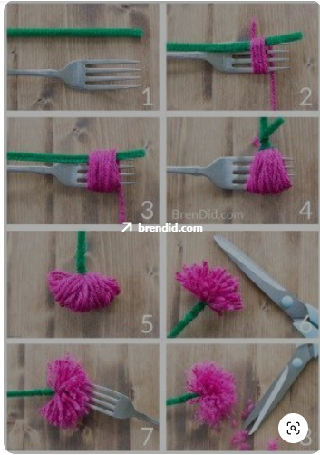If you have some wool or even string, have a go at making your own flower. If you don’t have a green pipe cleaner, just a bendy stick will do - try to find one that you can use to bend over in picture 4 and then tie it instead of twisting it. It doesn’t have to be fancy.
Thursday | 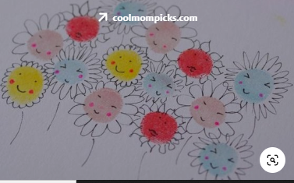  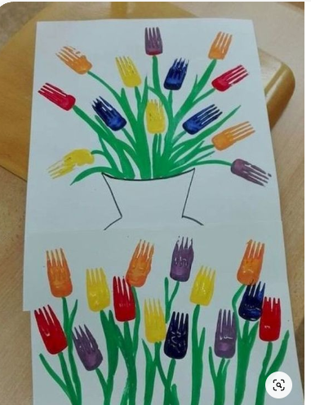This one looks like fun! Can you see the fork theme here? Make sure that you ask permission before using a fork to paint. If you don’t have any paint to hand, think about how else you could create a floral picture.
Friday | 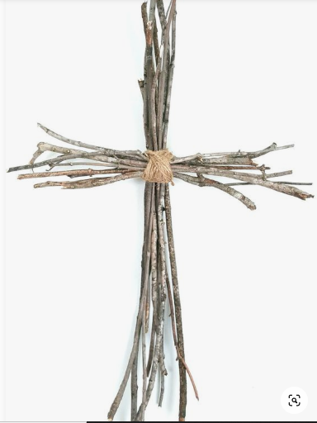Today, re-use that new skill of figure of eight lashing to make your own twig cross. You might like to write a prayer to go with it. In these strange times, you might like to think about some of the things that are good around you. Look closely!

