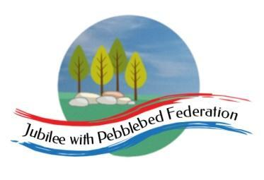

Class 2 Home Learning
For sessions in purple, please visit google classroom where you will find specific work related to each subject to complete and ‘turn in’.
Timings | 15 mins | 30 mins | 15 mins | 15 mins | 1 Hour | 1 Hour | 1 Hour
Monday | https://www.edshed.com/en-gb/login | Reading  https://www.activelearnprimary.co.uk/login?c=0 | https://ttrockstars.com/ | 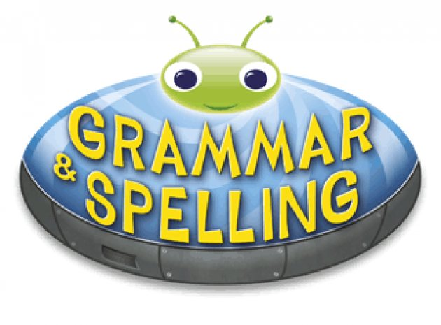  https://www.activelearnprimary.co.uk/login?c=0 | Maths  Follow the link for your year group for videos in the most current week. Then complete the worksheet provided on google classroom.  Children that do maths in the piano room  https://whiterosemaths.com/homelearning/year-2/  Year 3  https://whiterosemaths.com/homelearning/year-3/  Year 4  https://whiterosemaths.com/homelearning/year-4/  Year 5/6  https://whiterosemaths.com/homelearning/year-5/ | Literacy  L.O. To understand text cohesion. | Science  L.O. To group different types of rock.
Tuesday | https://www.edshed.com/en-gb/login | https://www.activelearnprimary.co.uk/login?c=0 | https://ttrockstars.com | https://www.activelearnprimary.co.uk/login?c=0 | Maths  Follow the link for your year group for videos in the most current week. Then complete the worksheet provided on google classroom.  Children that do maths in the piano room  https://whiterosemaths.com/homelearning/year-2/  Year 3  https://whiterosemaths.com/homelearning/year-3/  Year 4  https://whiterosemaths.com/homelearning/year-4/  Year 5/6  https://whiterosemaths.com/homelearning/year-5/ | Literacy  L.O. To understand why we use paragraphs. (Yr 3/4 )  L.O. To understand passive verb tenses. (Yr 5/6 ) | Topic  L.O. To explore the question ‘Why have people historically settled by rivers?’.
Wednesday | https://www.edshed.com/en-gb/login | https://www.activelearnprimary.co.uk/login?c=0 | https://ttrockstars.com | https://www.activelearnprimary.co.uk/login?c=0 | Maths  Follow the link for your year group for videos in the most current week. Then complete the worksheet provided on google classroom.  Children that do maths in the piano room  https://whiterosemaths.com/homelearning/year-2/  Year 3  https://whiterosemaths.com/homelearning/year-3/  Year 4  https://whiterosemaths.com/homelearning/year-4/  Year 5/6  https://whiterosemaths.com/homelearning/year-5/ | Topic  L.O. To explore Exeter, a settlement along the River Exe and Exmouth, the mouth of the River Exe. | RE  L.O. To understand how people felt about the disciples actions after pentecost.
Thursday | https://www.edshed.com/en-gb/login | https://www.activelearnprimary.co.uk/login?c=0 | https://ttrockstars.com | https://www.activelearnprimary.co.uk/login?c=0 | Maths  Follow the link for your year group for videos in the most current week. Then complete the worksheet provided on google classroom.  Children that do maths in the piano room  https://whiterosemaths.com/homelearning/year-2/  Year 3  https://whiterosemaths.com/homelearning/year-3/  Year 4  https://whiterosemaths.com/homelearning/year-4/  Year 5/6  https://whiterosemaths.com/homelearning/year-5/ | Literacy  L.O. To understand how structure helps readers understand tricky subjects. | PE  Premier sports have made some videos for you to follow at home for PE.  https://www.youtube.com/channel/UCLNV8D56t6RV0wbsPnbnYeA  Please do any of the ball skills on their channel.  You could also go out in the garden and get some fresh air or go for a walk with a grownup.  There are also some great videos to do on https://www.bbc.co.uk/teach/supermovers
Friday | https://www.edshed.com/en-gb/login | https://www.activelearnprimary.co.uk/login?c=0 | https://ttrockstars.com | https://www.activelearnprimary.co.uk/login?c=0 | Maths  Follow the link for your year group for videos in the most current week. Then complete the worksheet provided on google classroom.  Children that do maths in the piano room  https://whiterosemaths.com/homelearning/year-2/  Year 3  https://whiterosemaths.com/homelearning/year-3/  Year 4  https://whiterosemaths.com/homelearning/year-4/  Year 5/6  https://whiterosemaths.com/homelearning/year-5/ | Literacy  L.O. To use powerful noun phrases to describe. | PSHE  L.O. To explain the risks of smoking and identify strategies to resist any pressure to smoke.  French  L.O. To be able to write “I like…don’t like” a food in french.

