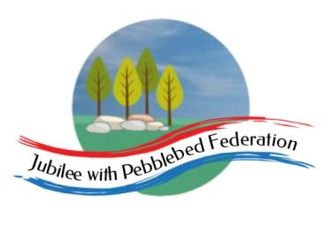

Class 2 Home Learning for the week beginning 23rd November
Each Day | Spelling  15 mins | 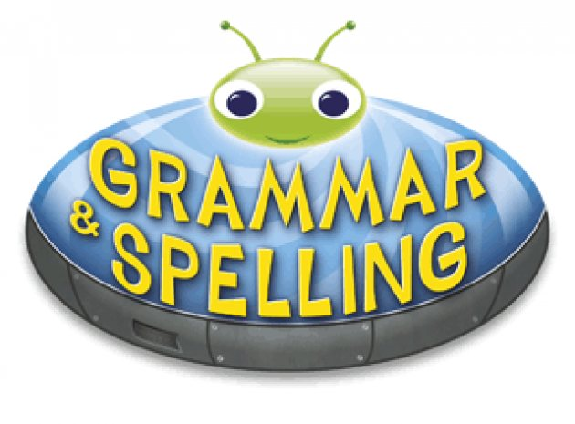  Grammar  15 mins | Reading  30 mins | Literacy 1 hour  Science 1 hour on Fridays |  | Maths (45 mins) when finished (15 mins)  Please follow the white rose maths links, complete any work on paper at home - do not buy the workbooks.  If your child is off for longer than 14 days - we can arrange for their power maths practise books to be collected.  PE (1 hour on Fridays) |  |  | Afternoon Project (1 hour)
Monday | Literacy Links:  Children normally with Miss Watts and Stella  https://classroom.thenational.academy/lessons/to-listen-to-a-story-c5h32r  Children normally with Miss Watts and Miss Richards  https://classroom.thenational.academy/lessons/to-develop-a-rich-understanding-of-words-associated-with-large-objects-6ru68d |  |  |  |  | Maths links for the week:  Children that do maths in the piano room  https://whiterosemaths.com/homelearning/year-2/week-10-measurement-money/  Year 3  https://whiterosemaths.com/homelearning/year-3/week-9-number-multiplication-division/  Year 4  https://whiterosemaths.com/homelearning/year-4/week-10-number-multiplication-division/  Year 5  https://whiterosemaths.com/homelearning/year-5/week-8-number-multiplication-division/  Year 6  https://whiterosemaths.com/homelearning/year-6/week-6-number-addition-subtraction-multiplication-division/ |  |  | RE  Read Noah’s Ark on this link below:  https://biblewise.com/kids/read/young/noahs-ark2.php  What kind of person was Noah? What promises did God make after the flood?  Draw an outline of Noah and write descriptive words inside.  Draw a rainbow, underneath write down a promise that you have made that you want to keep.
Tuesday | Literacy Links:  Children normally with Miss Watts and Stella  https://classroom.thenational.academy/lessons/to-tell-a-story-from-memory-71gkgr  Children normally with Miss Watts and Miss Richards  https://classroom.thenational.academy/lessons/to-analyse-and-interpret-a-setting-description-from-an-extract-c9k3jr |  |  |  |  |  |  |  | Topic  https://classroom.thenational.academy/lessons/why-did-the-romans-leave-britain-71k6cc
Wednesday | Literacy Links:  Children normally with Miss Watts and Stella  https://classroom.thenational.academy/lessons/to-explore-the-middle-of-a-story-6wukgd  Children normally with Miss Watts and Miss Richards  https://classroom.thenational.academy/lessons/to-practise-and-apply-knowledge-of-suffixes-ary-ery-c4r3ce |  |  |  |  |  |  |  | Topic  RESEARCH  Celtic clothing  This week in school, we are using batik and natural dyes to create celtic patterns in material.  What kind of clothes did the Celts they make/wear?  Why did they use natural materials?  Make a poster to show your findings.
Thursday | Literacy Links:  Children normally with Miss Watts and Stella  https://classroom.thenational.academy/lessons/to-vary-sentence-length-for-effect-c4rk6e  Children normally with Miss Watts and Miss Richards  https://classroom.thenational.academy/lessons/to-plan-the-opening-6rrk0e |  |  |  |  |  |  |  | PSHE  https://classroom.thenational.academy/lessons/king-of-the-road-6mu36t  French  https://www.youtube.com/watch?v=xRsr6wOIhgg
Friday | SCIENCE LINK:  https://classroom.thenational.academy/lessons/how-are-synthetic-materials-made-from-raw-materials-cdgk0e |  |  |  |  | PE  Here is a link to some videos a PE company (that Mr R comes from) has made for you.  https://www.youtube.com/channel/UCLNV8D56t6RV0wbsPnbnYeA  https://app.gonoodle.com/ Have a go at some fun dance/workout videos.  If you can: go outside and get some fresh air in the garden! What can you see, hear or smell? |  |  | 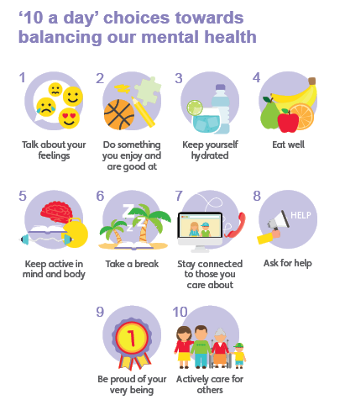  Mental Health  Have you done each of your ‘10 a day’?  Do something which makes you feel good :)

Well done for learning at home this week!

Please email into school anything you are proud of!

Miss Watts :)

