RE - What makes some places sacred to believers? Focus Religions: Christianity, Judaism, Islam

Elicitation task – January 2021.

Look at these pictures of holy places of worship and think carefully about what the places might be and why it might be important to a group of people.
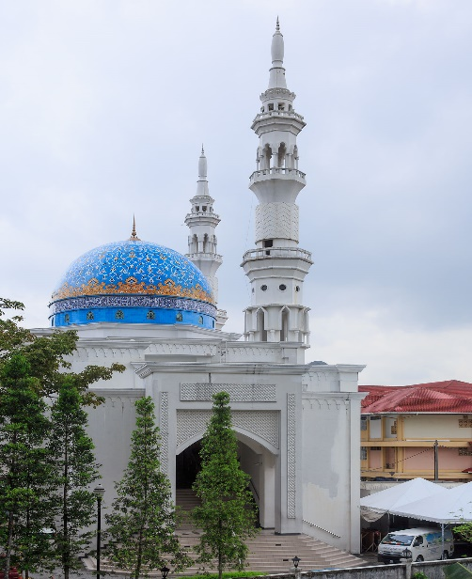

This place is called a _______________________________

What I know about this special building and why it is important to a group of people: ___________________

____________________________________________

____________________________________________
____________________________________________

____________________________________________

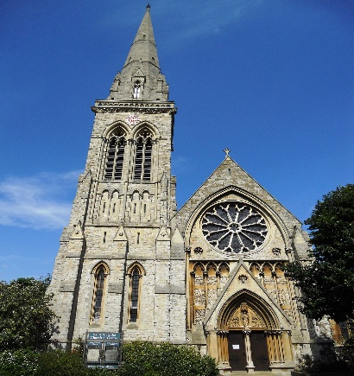
This place is called a _______________________________
This Photo by Unknown Author is licensed under CC BY-SA

What I know about this special building and why it is important to a group of people: ___________________

____________________________________________

____________________________________________
____________________________________________

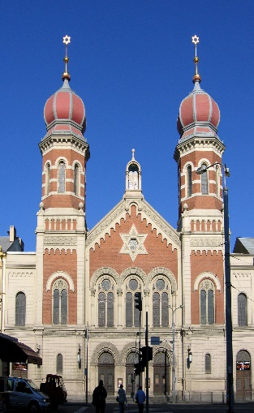
This place is called a _______________________________

What I know about this special building and why it is important to a group of people: ___________________

____________________________________________

____________________________________________
____________________________________________

____________________________________________

