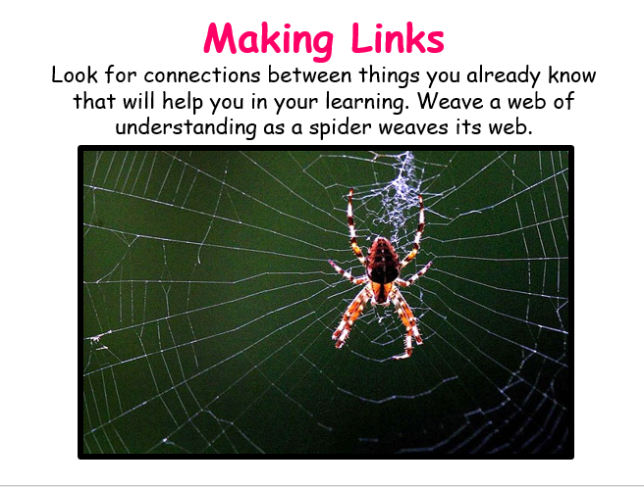

Class 2 Timetable 22.2.21 Learning animal of the week Mental Health 10 a day of the week
 | 9.10am  LIVE | 9:40-10.45  Maths lesson  then TT Rockstars | Break! | 11-12.15 Literacy  then Spelling Shed | Lunch  12:15-1:15 | 1:15-1:45  30 mins  Guided Reading | 1.45-2.10  SPAG | 2.10-3.10  Afternoon lesson | 3.10pm  LIVE
Mon | Daily Dashboard and Collective Worship | Piano Room Children  Elicitation/To recognise 2d and 3d shape.  https://whiterosemaths.com/homelearning/year-2/spring-week-7-geometry-properties-of-shapes/  Yellow sheets in books then  2B pg 104  Year 3  Elicitation/To understand bar charts.  https://whiterosemaths.com/homelearning/year-3/spring-week-5-statistics/  Yellow sheets in books then 3B pg 96  Year 4  To calculate fractions of a quantity.  https://classroom.thenational.academy/lessons/calculating-unit-fractions-of-quanties-6wvkgd  4B pg 152  Year ⅚  To subtract fractions by breaking the whole.  https://whiterosemaths.com/homelearning/year-6/week-11-number-fractions/  5B pg 124 | 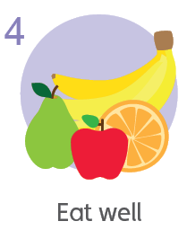  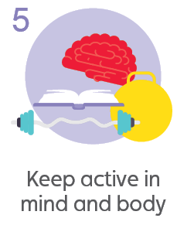  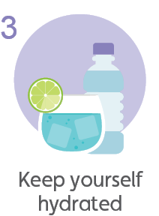  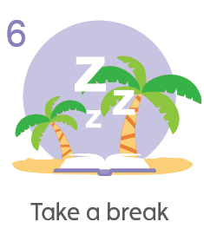 | 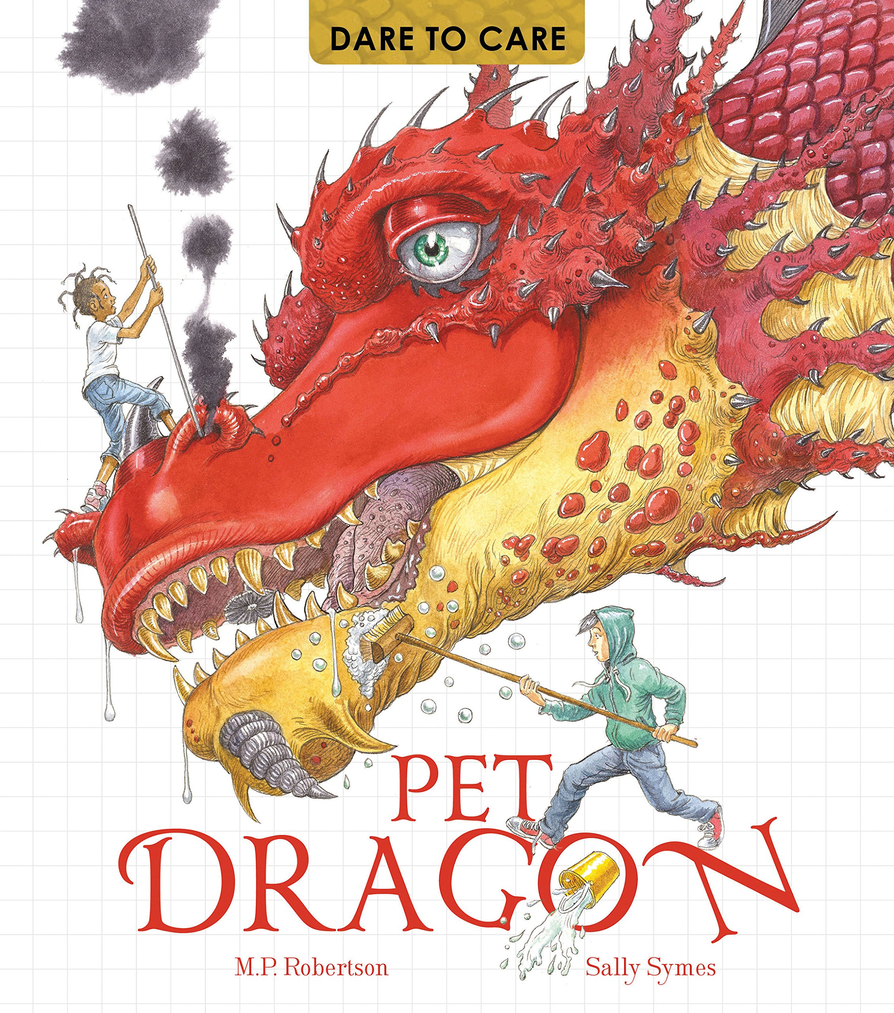  L.O. To use coordinating and subordinating conjunctions in sentences.  Today we will look at how sentences are joined by conjunctions in a variety of ways in the book. We will then write some of our own sentences to practise. |  | Bug Club reading with  Quiz | Bug Club Grammar | RE  L.O. To discuss life as a journey.  Our lives are one big journey. What changes or achievements have you been through so far?  Think of a growing tree…  Record your achievements on the branches and things you would like to achieve in the future on the leaves.  Think about some of the milestones that happen in the life of someone from particular religions. | End of day story
Tues | Daily Dashboard and Collective Worship | Piano Room Children  To draw 2d and 3d shapes.  https://whiterosemaths.com/homelearning/year-2/spring-week-7-geometry-properties-of-shapes/  2B pg 108  Year 3  To draw bar charts.  https://whiterosemaths.com/homelearning/year-3/spring-week-5-statistics/  3B pg 100  Year 4  To calculate fractions of a quantity.  https://classroom.thenational.academy/lessons/calculating-non-unit-fractions-of-quantities-cmtp4e  4B pg 156  Year ⅚  To subtract 2 mixed numbers.  https://whiterosemaths.com/homelearning/year-6/week-11-number-fractions/  5B pg 128 |  | L.O. To research and make notes on a creature from Viking mythology.  For your final piece of writing, you will be writing about looking after a mythological creature. In order to do this, you will need to choose a creature and find out as much as you can about it. |  | Bug Club reading with  Quiz | Bug Club Grammar | Topic - History  L.O. To understand who the Vikings were and why they invaded England.  In around AD 789, low ships appeared on the horizon off the coast of Wessex. The Vikings had arrived to begin many more years of violent invasion in Britain.  Watch videos on google classroom.  https://www.bbc.co.uk/bitesize/topics/ztyr9j6/articles/zjcxwty | End of day story
Wed | Daily Dashboard and Collective Worship | Piano Room Children  To count sides on 2d shapes.  https://whiterosemaths.com/homelearning/year-2/spring-week-7-geometry-properties-of-shapes/  2B pg 112  Year 3  To interpret tables.  https://whiterosemaths.com/homelearning/year-3/spring-week-5-statistics/  3B pg 108  Year 4  Consolidation  Year ⅚  To multiply unit fractions.  https://whiterosemaths.com/homelearning/year-6/week-11-number-fractions/  5B pg 144 |  | L.O. To write an introduction to a text about daring to care for a pet yeti.  Today, we will use the introduction from the text as a model, to write our own introduction on a text about a yeti (our class mythological creature). |  | 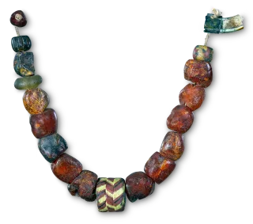  Bug Club reading with  Quiz | Bug Club Grammar | Topic - Geography  L.O. To understand where the Vikings came from.  Today we will look at maps of Europe to see where the Vikings came from.  The Vikings came from Norway, Sweden, Denmark and raided as far as Russia. They even discovered Iceland. The Vikings captured the northern English city of York in AD 866, with the city becoming known as Viking ‘Jorvik’. The Jorvik Viking Centre, a museum dedicated to the Viking history of the city, can be found in York today. | End of day story
Thur | Daily Dashboard and Collective Worship | Piano Room Children  To count vertices on 2d shapes.  https://whiterosemaths.com/homelearning/year-2/spring-week-7-geometry-properties-of-shapes/ 2B pg 116  Year 3  End of unit assessment.  https://whiterosemaths.com/homelearning/year-3/spring-week-5-statistics/  Blue sheets in books  Year 4  End of unit assessment.  https://classroom.thenational.academy/lessons/reasoning-with-fractions-c4vkje  Blue sheets in books  Year ⅚  To multiply non-unit fractions.  https://whiterosemaths.com/homelearning/year-6/week-11-number-fractions/  5B pg 148 |  | L.O. To write paragraphs using fronted adverbials and varied sentences about a yeti.  Today we will look at examples of fronted adverbials and use of paragraphs in the text and recreate this in writing about a yeti. |  | At school, PE at the moment is socially distanced fitness activities.  Premier sports have made some videos for you to follow at home for PE.  https://www.youtube.com/channel/UCLNV8D56t6RV0wbsPnbnYeA  Please do any of the fitness videos on their channel.  You could also go out in the garden and get some fresh air or go for a walk with a grownup.  There are also some great videos to do on https://www.bbc.co.uk/teach/supermovers |  |  | Read your own book today :)
Fri | Daily Dashboard and Collective Worship | Science  L.O. To classify ALL types of animal.  Classifying animals  Last half term we classified animals into six main groups, based on certain characteristics.  RECAP - Zoo classification sheet.  There are 5 further groups to learn - Arachnids, Annelids, Molluscs, Crustaceans and Echinoderms.  https://www.bbc.co.uk/bitesize/topics/zn22pv4/articles/z3nbcwx  Classifying animals  https://www.bbc.co.uk/bitesize/topics/z2ddmp3/articles/zccm3k7 |  | French - 30 mins  To understand infinitive verbs.  https://www.bbc.co.uk/bitesize/topics/z6d98xs/articles/zy9dg7h  Bug Club Grammar 15 mins  TTRockstars  15 mins |  | Bug Club reading with  Quiz | Bug Club Grammar | PSHE - 30 mins  L.O. To understand and know how to manage feelings of jealousy  https://www.bbc.co.uk/teach/class-clips-video/pshe-ks2-dealing-with-jealousy-in-relationship/zrrdt39  Mental Health  30 mins  Take this time to go onto the mental health section of google classroom.  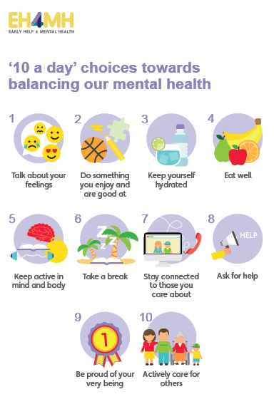  Think about doing something towards your 10 a day. | LIVE  SHARING ASSEMBLY

