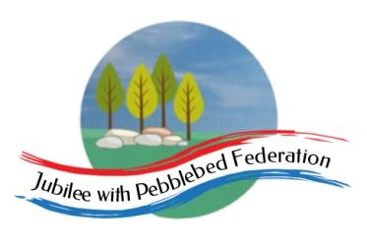

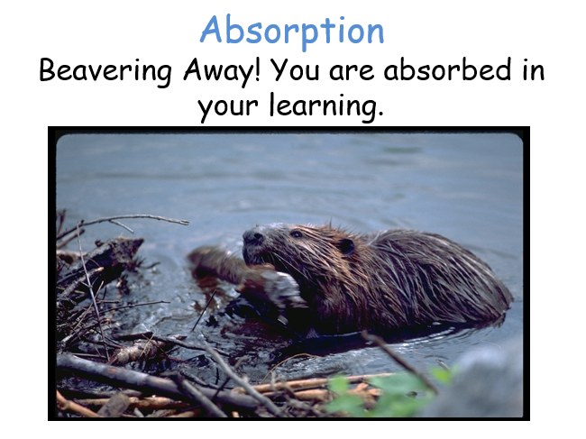
Class 2 Weekly Home Learning Timetable 8.2.21 - LIVE GOOGLE MEETS
Learning animal of the week - see topic on google classroom for more information - please fill in a slip each week to let me know how you are learning at home.
Timings | 9.10am  LIVE | 1 hour (45 mins then 15 mins TT) | 1 hour | 1 hour | 15 mins | 30 mins | 15 mins | 3.10pm  LIVE
Monday  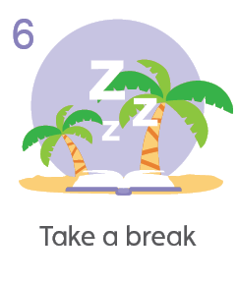10 a day mental health of the day | Daily Dashboard and Collective Worship | Piano Room Children  To interpret pictograms.  https://whiterosemaths.com/homelearning/year-2/ Week 6  Google classroom sheet to do.  2B pg 64  Year 4  To subtract fractions from whole amounts.  https://classroom.thenational.academy/lessons/subtracting-fractions-2-71k34d  Google classroom sheet to do.  4B pg 136  Year 5/6  To add mixed numbers.  https://whiterosemaths.com/homelearning/year-6/week-10-number-fractions/  Google classroom sheet to do.  5A pg 104 6A pg 152 | L.O. To become familiar with our text ‘ Dare to Care: Pet Dragon’.  Today, you will all be introduced to our new text for our non-fiction writing sequence.  The final outcome for this piece of work is to write a page of advice on looking after a creature or object.  In this lesson, you will memorise the introduction and conclusion of the text. This will help you write introductions and conclusions of your own in a few weeks time.  Google classroom resources and sheet to do. | RE  L.O To answer the question: How does following God bring freedom and justice.  Today we will sum up everything we have learnt this half term and complete our blue assessment sheet. | Bug Club Grammar | Bug Club reading with  Quiz | Spelling | End of day story  Anglo Saxon Boy
Tuesday  10 a day mental health of the day  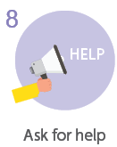 | Daily Dashboard and Collective Worship | Piano Room Children  To understand block diagrams.  https://whiterosemaths.com/homelearning/year-2/ Week 6  Google classroom sheet to do.  2B pg 68  Year 4  To calculate fractions of a quantity.  https://classroom.thenational.academy/lessons/calculating-unit-fractions-of-quanties-6wvkgd  https://classroom.thenational.academy/lessons/calculating-non-unit-fractions-of-quantities-cmtp4e  Google classroom sheet to do.  4B pg 148  Year 5/6  To add fractions.  https://whiterosemaths.com/homelearning/year-6/week-10-number-fractions/  Google classroom sheet to do.  5A pg 108/112 | L.O. To understand the purpose of our class text.  Today, we will think about what we like, dislike, any patterns or puzzles we have and the purpose of the text.  Google classroom resources and sheet to do. | SAFER INTERNET DAY  BBC are doing a live lesson at 11am at the link below  https://www.bbc.co.uk/teach/live-lessons/safer-internet-day-live-lesson/zdh2wnb  First, watch this film  https://www.saferinternet.org.uk/safer-internet-day/safer-internet-day-2021/i-am-educator/safer-internet-day-2021-films  Then, take this quiz  https://www.saferinternet.org.uk/safer-internet-day/safer-internet-day-2021/safer-internet-day-2021-quiz.  Google classroom sheet to do. | Bug Club Grammar | Bug Club reading with  Quiz | Spelling | End of day story  Anglo Saxon Boy
Wednesday  10 a day mental health of the day  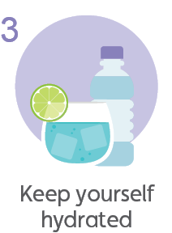 | Daily Dashboard and Collective Worship | Piano Room Children  https://whiterosemaths.com/homelearning/year-2/ Week 6  Google classroom sheet to do.  Year 4  To problem solve with fractions.  https://classroom.thenational.academy/lessons/reasoning-with-fractions-c4vkje  Google classroom sheet to do.  4B pg 140  Year 5/6  To subtract fractions.  https://whiterosemaths.com/homelearning/year-6/week-10-number-fractions/  Google classroom sheet to do.  5B pg 116 | L.O To understand the purpose of paragraphs and subheadings in the text.  Today we will look at paragraphs and subheadings in the text - particularly in the introduction sections. We will think about their purpose and importance.  Google classroom resources and sheet to do. | Topic - DT  L.O. To design and make Anglo-Saxon charms from clay.  On Friday, you will make small Anglo-Saxon charms by rolling and cutting clay/salt dough. Today you need to draw some designs, which shapes will you create? Will you have patterns on your shapes? What colours will you paint them?  See google classroom presentation.  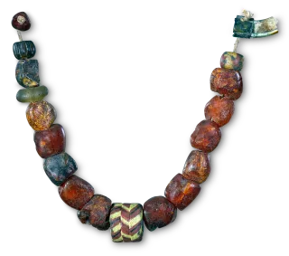  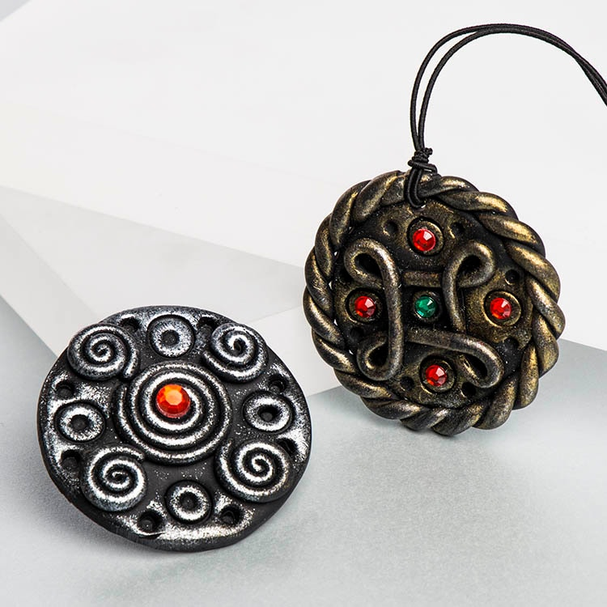 | Bug Club Grammar | Bug Club reading with  Quiz | Spelling | End of day story  Anglo Saxon Boy
Thursday  10 a day mental health of the day  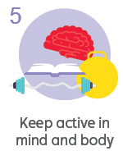 | Daily Dashboard and Collective Worship | Piano Room Children  https://whiterosemaths.com/homelearning/year-2/ Week 6  Google classroom sheet to do.  Year 4  To understand tenths and hundredths.  https://classroom.thenational.academy/lessons/tenths-and-hundredths-6nj68c  Google classroom sheet - Thinking Tom set 4 pages 29 and 35.  Year 5/6  To subtract mixed numbers.  https://whiterosemaths.com/homelearning/year-6/week-10-number-fractions/  Google classroom sheet to do.  5B pg 120 | Piano room/Yr 3 and 4:  L.O. To use coordinating conjunctions.  Year 5/6: L.O To use subordinating conjunctions. | PE  At school, PE at the moment is socially distanced fitness activities.  Premier sports have made some videos for you to follow at home for PE.  https://www.youtube.com/channel/UCLNV8D56t6RV0wbsPnbnYeA  Please do any of the fitness videos on their channel.  You could also go out in the garden and get some fresh air or go for a walk with a grownup.  There are also some great videos to do on https://www.bbc.co.uk/teach/supermovers  See special video from ECFC’s Callum on google classroom | Bug Club Grammar | Bug Club reading with  Quiz | Spelling | Read your own book today :)
Friday  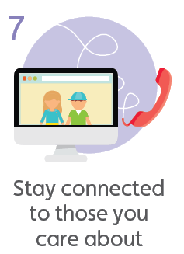  10 a day mental health of the day | Daily Dashboard and Collective Worship | Science  L.O. To describe the differences in the life cycles of an insect and a bird.  Last week, you compared mammal and amphibian life cycles. Watch these same clips below.  https://www.bbc.co.uk/teach/class-clips-video/science-ks2--ks3-the-life-cycles-of-different-organisms/zvh8qp3  https://www.bbc.co.uk/bitesize/topics/zgssgk7/articles/zwn6mnb  Google classroom sheet to do. | Mental Health 30 mins  Take this time to go onto the mental health section of google classroom.  Think about doing something towards your 10 a day.  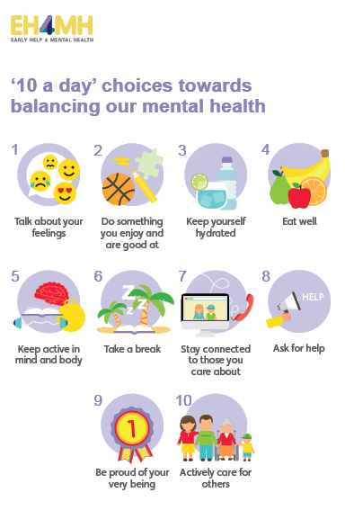  TT Rockstars - 15 mins  Bug Club reading with  Quiz 15 mins | Topic - DT  L.O. To design and make Anglo-Saxon charms from clay.  Now you have designed your charm for your Anglo-Saxon necklace, you can make it!  Follow these instructions  https://www.twinkl.co.uk/homework-help/history-homework-help/anglo-saxons-facts-for-kids/make-your-own-saxon-clay-craft  Thread their charms onto a cord along with other materials, such as glass, wood, shell or bone beads, to create a personalised necklace.  It is likely you won’t have clay at home.  Here is a recipe for salt dough, which will work the same!  https://www.bbcgoodfood.com/howto/guide/how-make-salt-dough-recipe  Send me a picture of your necklaces, I can’t wait to see them! | Bug Club Grammar | Bug Club reading with  Quiz | Spelling | LIVE  SHARING ASSEMBLY  