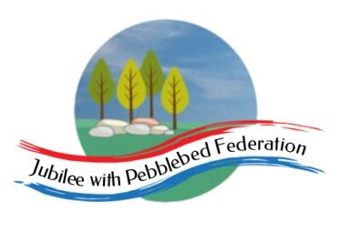

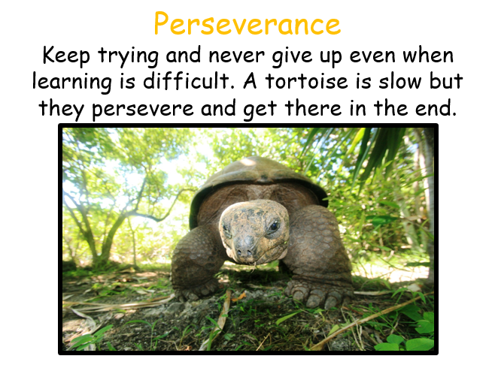
Class 2 Weekly Home Learning Timetable 25.1.21
Learning animal of the week - see topic on google classroom for more information!

Timings | 30 mins | 1 hour (45 mins then 15 mins TT) | 1 hour | 1 hour | 15 mins | 30 mins | 15 mins | 20 mins
Monday  Learning behaviour animal of week  10 a day mental health of the day | Daily Dashboard and Collective Worship  PPT on GC  MENTAL HEALTH MONDAY  - Follow link in daily dash | Piano Room Children  To divide by 10.  Watch video on dividing by 10 here https://whiterosemaths.com/homelearning/year-2/ spring week 4  Google classroom sheet to do.  2B pg 28  Year 4  You all did excellently at area last week!  This week, you start fractions!  On google classroom there is a yellow elicitation sheet for me to see what you know already, please complete independently.  Year 5/6  To convert improper fractions to mixed numbers.  Watch this video https://whiterosemaths.com/homelearning/year-6/week-8-number-fractions/  Google classroom sheet to do.  5B pg 60 | Piano Room Children  L.O. To understand the structure of the story.  Today we will use a text structure chart to understand the story’s order and key events.  Google classroom sheet to do.  Everyone else  L.O. To understand the structure of the story.  Today we will use a text structure chart to understand the story’s order and key events.  Google classroom sheet to do. | RE  L.O. To research a Christian charity that seeks to bring freedom and justice - just like Jesus.  Many Christian people see Jesus as bringing a new covenant — a new relationship with God. His teachings and actions showed them how to live. Look at the two greatest commandments Jesus reminds listeners of in Matthew 22:37–40.  Google classroom sheet to do. | Bug Club Grammar | Bug Club reading with  Quiz | Spelling | Read a book or listen to Miss Watts reading the new class book  Anglo-Saxon Boy!
Tuesday  Learning behaviour animal of the day  10 a day mental health of the day | Daily Dashboard and Collective Worship  PPT on GC | Piano Room Children  Today you will apply all the work you have done on multiplying and dividing to problems.  Watch this video https://classroom.thenational.academy/lessons/solving-multiplication-and-division-problems-69h66d  Google classroom sheet to do.  2B page 40 and 2A pg 216  Year 4  To know what a fraction is.  Watch this video https://classroom.thenational.academy/lessons/name-unit-fractions-and-match-them-with-the-fraction-notation-and-a-representation-chgk8c  Google classroom sheet to do.  4B pg 96  Year 5/6  To convert mixed numbers to improper fractions.  Watch this video https://whiterosemaths.com/homelearning/year-6/week-9-number-fractions/  Google classroom sheet to do.  5B pg 64 | Piano Room Children  L.O. To use opposites to think about ideas for a story.  Google classroom sheet to do.  Everyone else  L.O. To generate ideas for a story in which a character develops through the course of an adventure.  Today, we will start to think about ways a character might change in a story - in preparation for writing your own stories.  Google classroom sheet to do. | Topic - Art  This week we are thinking about Anglo Saxon art.  Watch this video about their art and treasure.  https://www.bbc.co.uk/bitesize/topics/zxsbcdm/articles/zwjq2hv  Today we will look at Anglo Saxon patterns and complete some sketches/designs for our own versions tomorrow. | Bug Club Grammar | Bug Club reading with  Quiz | Spelling | Read a book or listen to Miss Watts reading the new class book  Anglo-Saxon Boy!
Wednesday  Learning behaviour animal of the day  10 a day mental health of the day  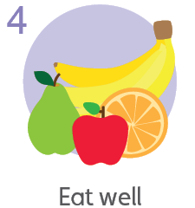 | Daily Dashboard and Collective Worship  PPT on GC | Piano Room Children  You have now finished multiplication and division - you have two jobs to do on google classroom today.  Year 4  To understand equivalent fractions.  https://classroom.thenational.academy/lessons/compare-unit-fractions-using-a-fraction-wall-6gr30d  Google classroom sheet to do.  4B pg 104  Year 5/6  To sequence fractions (on a numberline).  Watch this video https://whiterosemaths.com/homelearning/year-6/week-9-number-fractions/  Google classroom sheet to do.  5B pg 68 6A 132 | Piano Room Children  L.O. To plan a story where a character goes on an adventure and changes. See google classroom.  Everyone else  L.O. To develop a cohesive plan for a story in which a character develops through the course of an adventure or challenge.  Today we will plan your story in readiness for starting to write it tomorrow.  Google classroom sheet to do. | Topic - Art  Today we will investigate printing techniques (https://www.accessart.org.uk/curriculum-planning-printmaking/ ) and use a polystyrene tile and/or string stuck on cardboard to create a printing tile in an Anglo-Saxon design.  If you do not have any paint or other resources at home - draw another design as yesterday. | Bug Club Grammar | Bug Club reading with  Quiz | Spelling | Read a book or listen to Miss Watts reading the new class book  Anglo-Saxon Boy!
Thursday  Learning behaviour animal of the day  10 a day mental health of the day  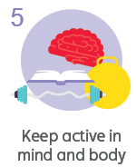 | Daily Dashboard and Collective Worship  PPT on GC | Piano Room Children  We are starting statistics in maths - this involves tally charts, pictograms and block diagrams.  Please complete the sheet on google classroom on your own so I know what to teach you about statistics!  Year 4  To understand equivalent fractions.  Watch this video https://classroom.thenational.academy/lessons/reason-about-comparing-unit-fractions-6mr68e  Google classroom sheet to do.  4B pg 108  Year 5/6  To compare and order fractions less than 1.  Watch this video https://whiterosemaths.com/homelearning/year-6/week-9-number-fractions/  Google classroom sheet to do.  5B pg 72 6A 136 | 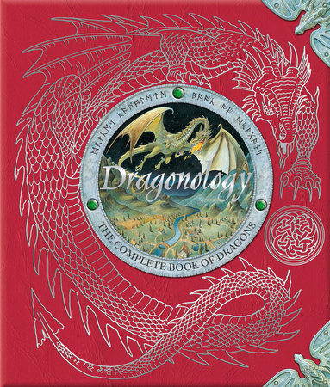  Piano Room Children  Everyone else  DRAGONOLOGY  Today you will do some writing based on some pictures for our next literacy sequence.  I would like to see how you write information or nonfiction writing. | PE  At school, PE at the moment is socially distanced fitness activities.  Premier sports have made some videos for you to follow at home for PE.  https://www.youtube.com/channel/UCLNV8D56t6RV0wbsPnbnYeA  Please do any of the fitness videos on their channel.  You could also go out in the garden and get some fresh air or go for a walk with a grownup.  There are also some great videos to do on https://www.bbc.co.uk/teach/supermovers | Bug Club Grammar | Bug Club reading with  Quiz | Spelling | Read a book or listen to Miss Watts reading the new class book  Anglo-Saxon Boy!
Friday  Learning behaviour animal of the day  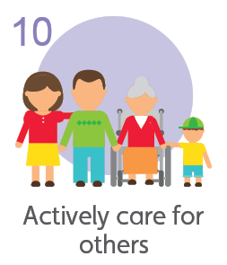  10 a day mental health of the day | Daily Dashboard and Collective Worship  PPT on GC | Science  To understand how environments can change.  Watch this video - and complete the activities/quizzes  https://www.bbc.co.uk/bitesize/topics/zp22pv4/articles/z2md82p  As a class, you are all very aware of environmental changes and climate change.  Today’s lesson is about environmental changes, dangers and endangered animals.  Google classroom sheet to complete. | French - 30 mins  Go to this link  https://www.bbc.co.uk/bitesize/topics/zjcbrj6/articles/zcqsxbk  Google classroom sheet to complete.  TT Rockstars - 15 mins  Bug Club reading with  Quiz 15 mins | PSHE 30 mins  Today we will look at ‘in app purchases’ and spending money online.  Google classroom sheet to complete.  Sharing Assembly  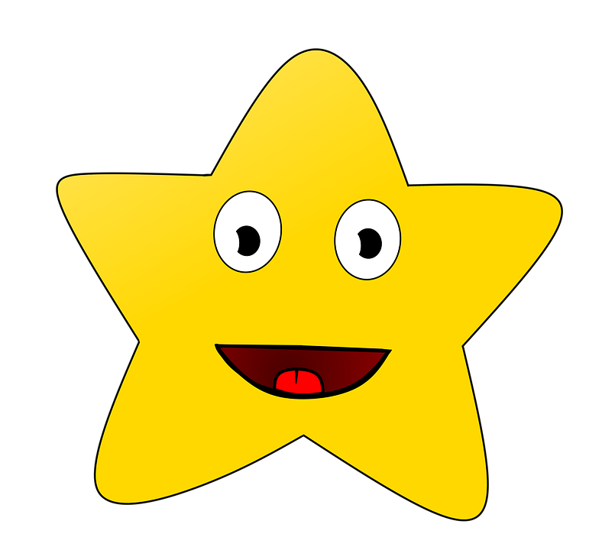  This week is our first google meet sharing assembly at 3.00pm - check google classroom for the link | Bug Club Grammar | Bug Club reading with  Quiz | Spelling | Read a book or listen to Miss Watts reading the new class book  Anglo-Saxon Boy!

