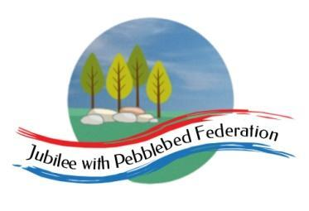

Class 1 Home Learning for the week beginning 17th October
 | Phonics (30 mins) | Reading (30 mins) | Writing (30 mins) | Maths (30 mins) | Afternoon Project
Monday | 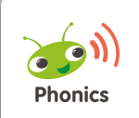  Please log into your Bug Club account where I will have allocated games for phonics.  Reception  c as in c  Year 1  ai as eigh, ey and ei  Year 2  n as kn and gn | https://www.activelearnprimary.co.uk/login?c=0  Check your account for book allocations. | https://www.bbc.co.uk/bitesize/articles/zkn3bdm  Watch the first video - features of a newspaper report, practise using the activity supplied. Now complete the quiz together with the children to put the labels into the correct place.  Now look at the reports attached and use colours to identify the who, what, where, why and when . | Reception  https://classroom.thenational.academy/specialist/subjects/numeracy/access-points/building-understanding/lessons/counting-to-5-c4u3gd  Year 1  Coin and Note Recognition  https://classroom.thenational.academy/lessons/to-recognise-the-value-of-different-coins-and-notes-65j64e  Year 2  Spending up to £20 in coins and notes  https://classroom.thenational.academy/lessons/to-exchange-money-for-items-crv3je | RE  https://www.bbc.co.uk/programmes/p06ypq04  Watch the story of ‘Jonah and the Whale’.  Think about which were the best bits. Did any bits puzzle you - why? Can you tell me what your feelings were like in the story? Is there a hidden meaning in the story for Christians to understand?  Think about the following questions:  - What happened when Jonah tried to run away from God?  - How did God find Jonah?  - Was it important for Jonah to go to Nineveh — why?  Create a Christmas Card  See details below  If possible, please get your design back to school by Thursday so that we can get them sent off.
Tuesday | Reception  k as in c  Year 1  Language session  Year 2  r as wr | https://www.activelearnprimary.co.uk/login?c=0 | Listen to the podcast of the Katie Morag story and then complete the who, what, where, why when grid (see resources) for the Katie Morag story.  https://www.bbc.co.uk/newsround/50434875  Resources:  Podcast  Grid | Reception  https://classroom.thenational.academy/specialist/subjects/numeracy/access-points/building-understanding/lessons/counting-to-5-c4u3gd  Year 1  Equivalent values  https://classroom.thenational.academy/lessons/to-recognise-the-value-of-different-coins-and-notes-65j64e  Year 2  Totals of coins and notes  https://classroom.thenational.academy/lessons/to-compare-different-amounts-of-money-6gwk8c?activity=video&step=2 | Science Week  See whether you can re-create this at home.  Study of earthworms in the garden  - Carefully collect an earthworm each from the garden and place it on a piece of see through plastic.  - Measure your earthworm from head to tail and record.  - Weigh your earthworm and record  - Record where in the garden you located your worm.  - Now using the magnifying glass and drawing scientifically, sketch a picture of your earthworm.  - Release your earthworm carefully back into the garden.
Wednesday | Reception  language session  Year 1  ee as in ea  Year 2  Language session | https://www.activelearnprimary.co.uk/login?c=0 | Now read my newspaper report and underline the who, what, where, why and when in my report. Use the same colours as for Monday.  Now have a go at writing sentences (Y1 - 1 sentence for each section, Y2 - at least 2 or 3 sentences for eah section). Remember to write in past tense as it has already happened. | Reception  https://classroom.thenational.academy/specialist/subjects/numeracy/access-points/building-understanding/lessons/counting-to-5-c4u3gd  Year 1  Understanding part-whole  https://www.ictgames.com/mobilePage/partPartWhole/index.html  This is a great game. Drag ones counters (whichever you choose) to make the parts of the whole. You can choose whichever types of objects you wish. Make your own cherry model at home out of anything and use household things to show the whole and the parts for numbers up to 10.  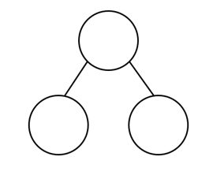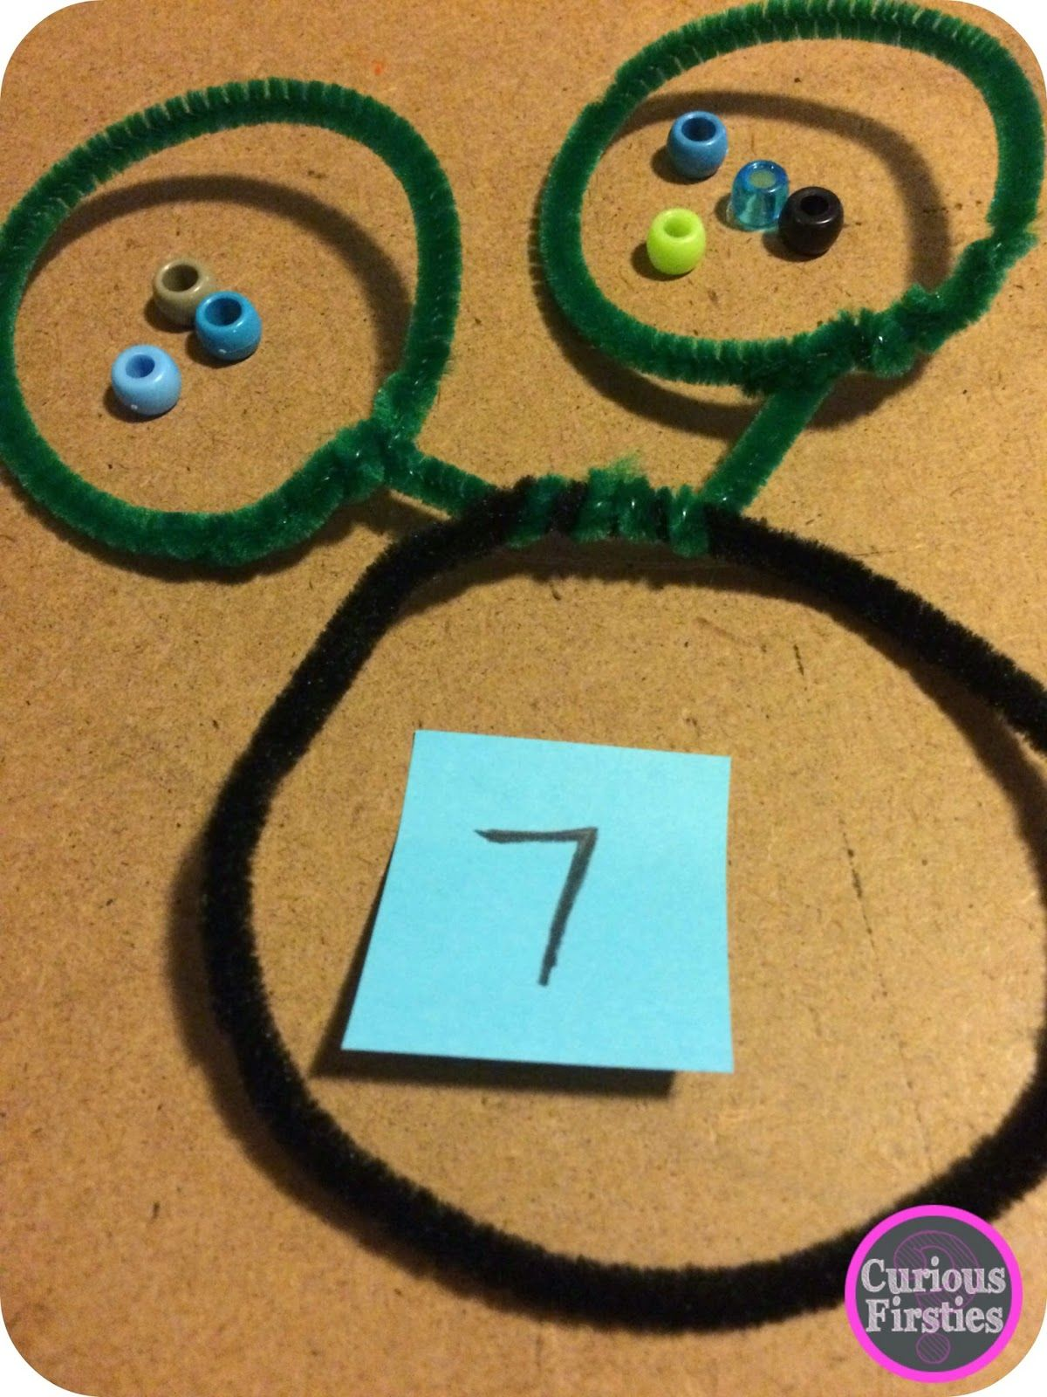  Year 2  Add and subtract ones  https://teachers.thenational.academy/lessons/adding-and-subtracting-ones-from-a-2-digit-number-60wkar | Geography  https://www.bbc.co.uk/bitesize/clips/zqsgkqt  In order to consolidate your understanding of this,  Make a model using anything that you have available, of coastlines featuring caves, arches and stacks. Use these models to explain how different features are formed through the process of weathering and erosion. Send me a photograph of your creations with your labelling.
Thursday | Reception  ck as in c  Year 1  Tricky words for this week.  be, he, me, she, we  Year 2  Tricky words for this week.  find, mind, kind, behind, child | https://www.activelearnprimary.co.uk/login?c=0 | Today, use things that you have at home to recreate the scene of the Isle of Struay and the new pier. When you have done this, take a photograph and try to caption it for your newspaper report. | Reception  https://classroom.thenational.academy/specialist/subjects/numeracy/access-points/building-understanding/lessons/counting-to-5-c4u3gd  Year 1  Understanding part-whole  https://classroom.thenational.academy/lessons/understanding-commutativity-c5gk8c  Year 2  Ten more ten less  https://teachers.thenational.academy/lessons/adding-and-subtracting-tens-from-a-2-digit-number-69h3jt | Computing - Tallest Tower  See below for details. Obviously, the children will not be able to work in groups, but maybe you could work together with your child on this task.
Friday | NON PUPIL DAY

